LoadBalancer-Assignment-01

- Configure Classic Load balancer.
The Classic Load Balancer (CLB) is an AWS service that automatically distributes incoming traffic across multiple Amazon EC2 instances to ensure high availability and fault tolerance. It is primarily designed to handle HTTP, HTTPS, and TCP traffic.

1. Task Title: Configure Classic Load Balancer.
2. Objective:
To configure a Classic Load Balancer in AWS that distributes incoming HTTP traffic across multiple EC2 instances deployed in two public subnets, ensuring high availability and scalability.
3. Prerequisites:
• A VPC created with DNS hostnames enabled
• Two public subnets created
• Internet Gateway attached
• Proper route tables configured
• EC2 instances launched in both public subnets
• Apache installed on EC2 instances with a working index.html
• Security group allowing HTTP (80)

4.Step-by-Step Implementation (With Evidence):

Step 1: Create VPC
Console path / CLI command: VPC Dashboard → Create VPC
Explanation: Creation of a dedicated VPC for load balancer deployment.
Evidence: 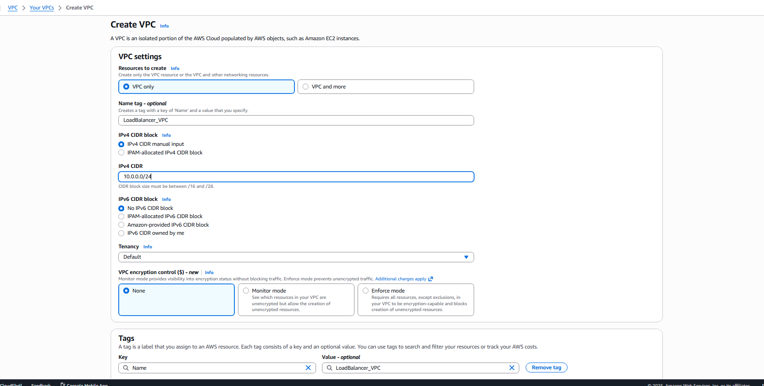

Step 2: Verify VPC creation
Console path / CLI command: VPC Dashboard → Your VPCs
Explanation: Confirms VPC is created with correct CIDR and settings.
Evidence: 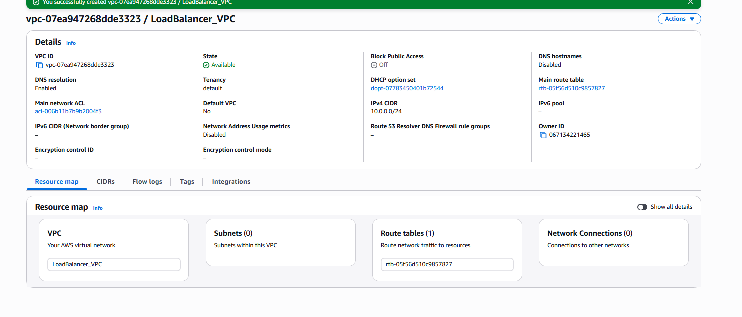

Step 3: Create public subnets
Console path / CLI command: VPC → Subnets → Create subnet
Explanation: Two public subnets created for multi-AZ load balancing.
Evidence: 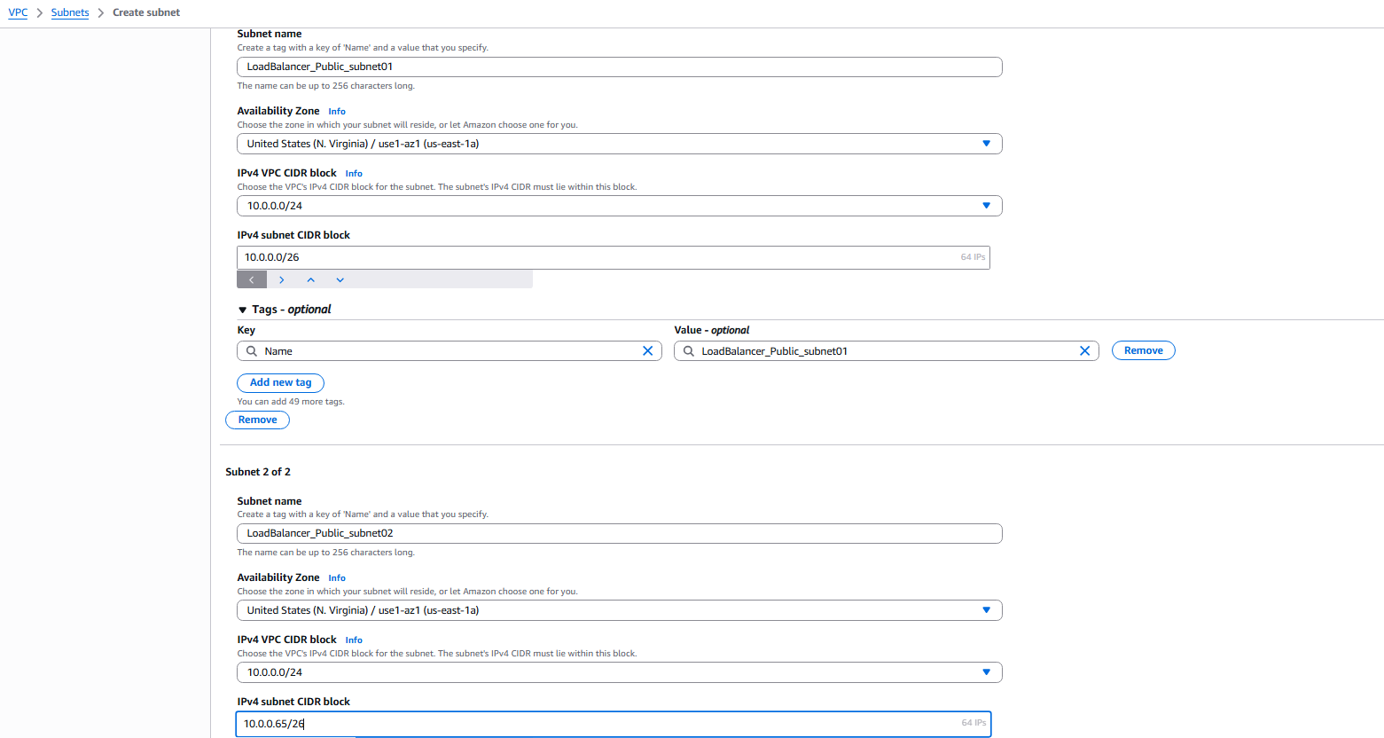

Step 4: Confirm subnets
Console path / CLI command: VPC → Subnets
Explanation: Ensures subnets were created successfully.
Evidence: 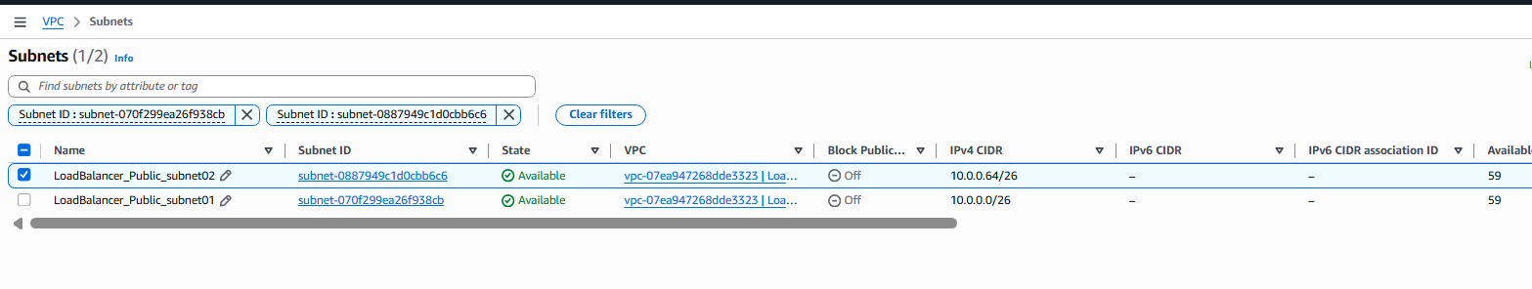

Step 5: Configure route tables for internet access
Console path / CLI command: VPC → Route Tables
Explanation: Public subnets must have a route to the Internet Gateway.
Evidence: 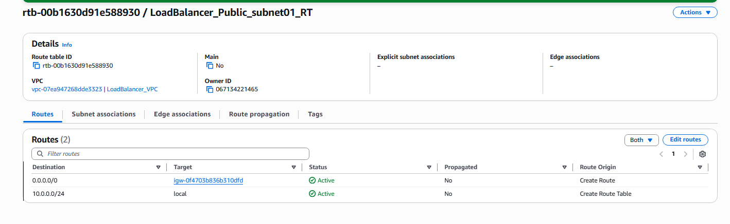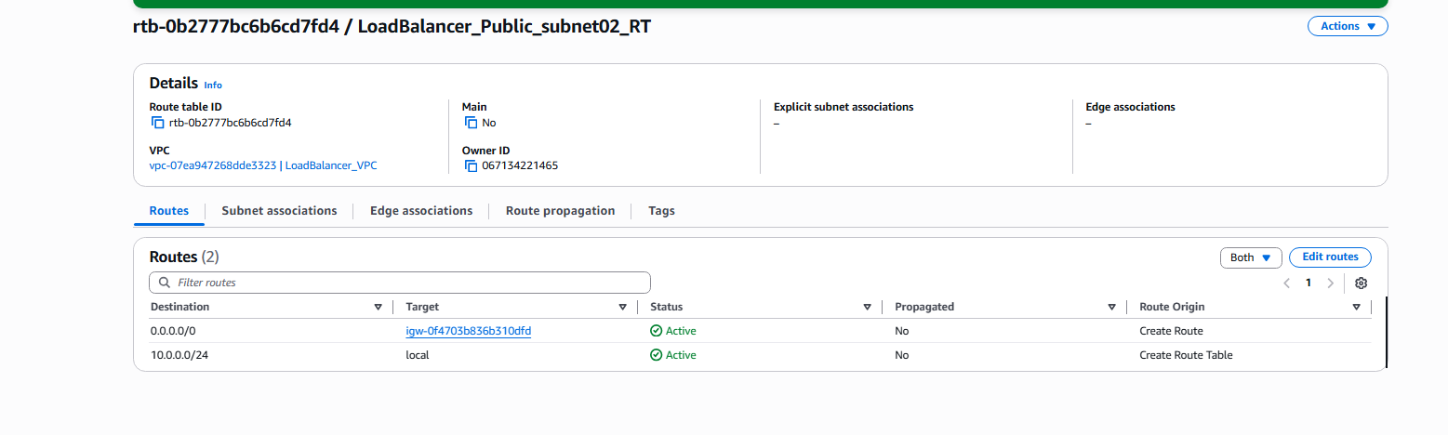

Step 6: Verify VPC resource map
Console path / CLI command: VPC → Resource Map
Explanation: Confirms the VPC architecture is properly connected.
Evidence: 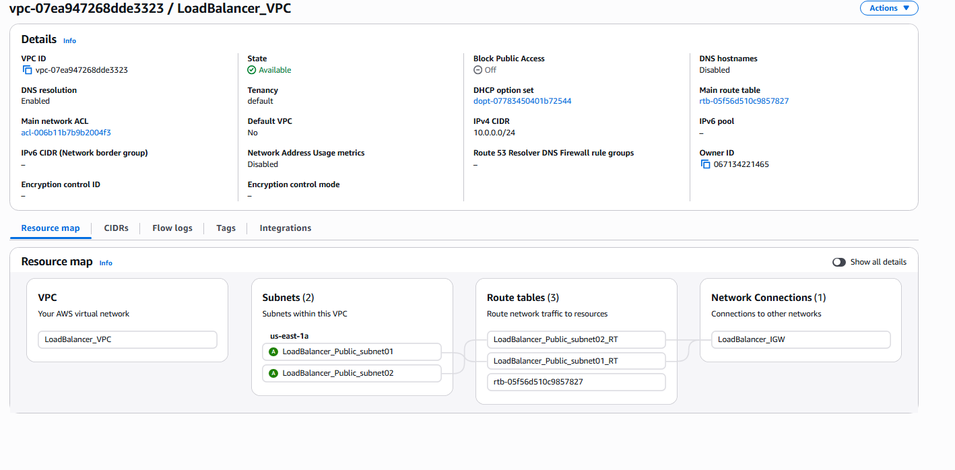

Step 7: Initiate Classic Load Balancer creation
Console path / CLI command: EC2 → Load Balancers → Create Load Balancer → Classic
Explanation: Defines CLB properties including scheme and listeners.
Evidence: 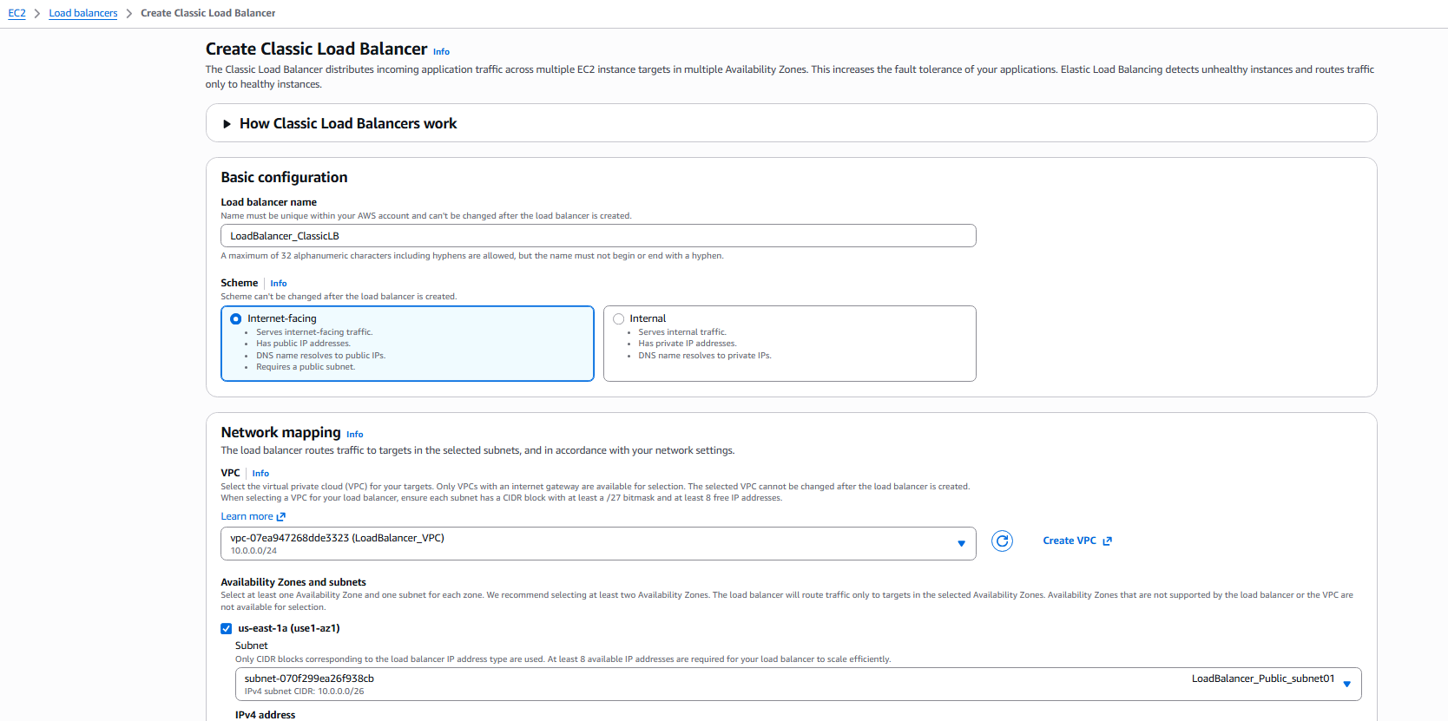

Step 8: Launch EC2 instances for subnet01
Console path / CLI command: EC2 → Launch instance
Explanation: Instances serving as backend targets for CLB.
Evidence: 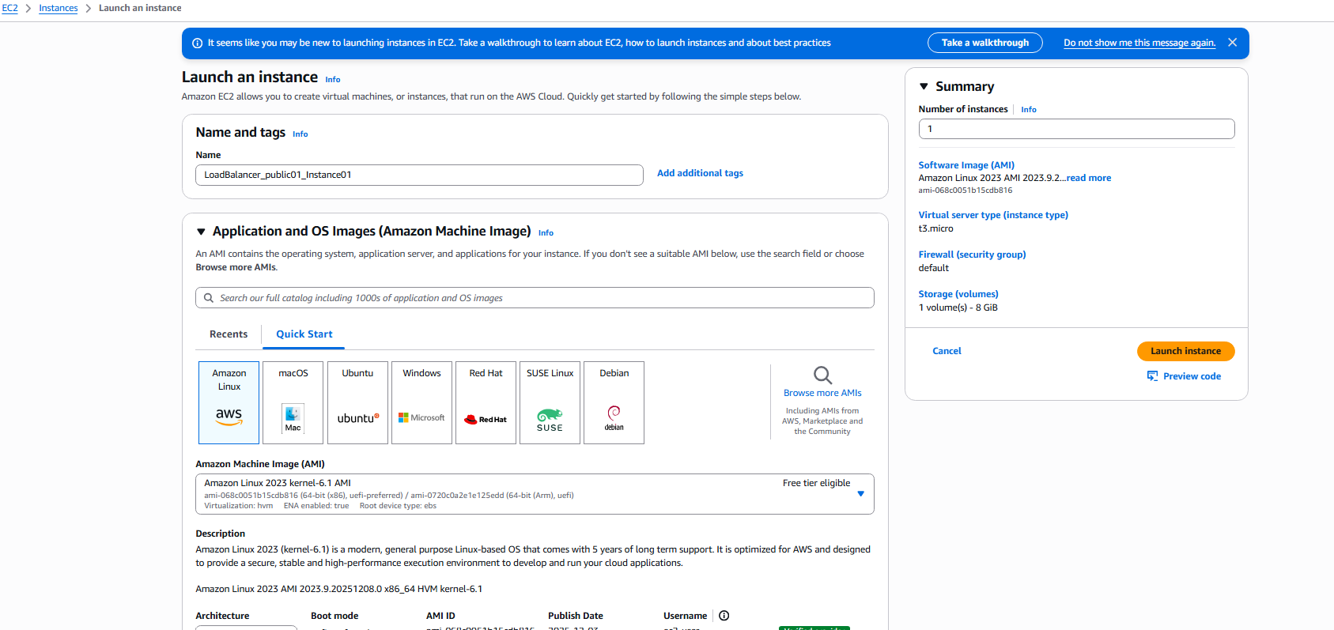

Step 9: Provide User Data for EC2 instance
Console path / CLI command: Launch Instance → Advanced details
Explanation: Installs Apache and configures index.html.
Evidence: 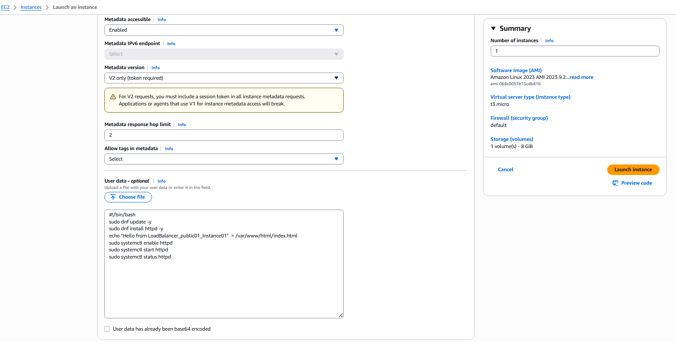

Step 10: Verify instance launch
Console path / CLI command: EC2 → Instances
Explanation: Confirms instance running with required configuration.
Evidence: 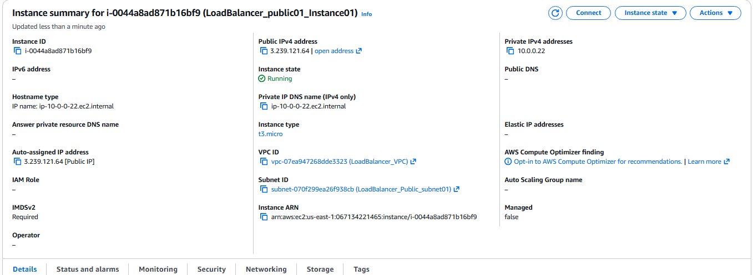

Step 11: Launch EC2 instance in second subnet
Console path / CLI command: EC2 → Launch instance
Explanation: Ensures load balancer has multiple backend nodes.
Evidence: 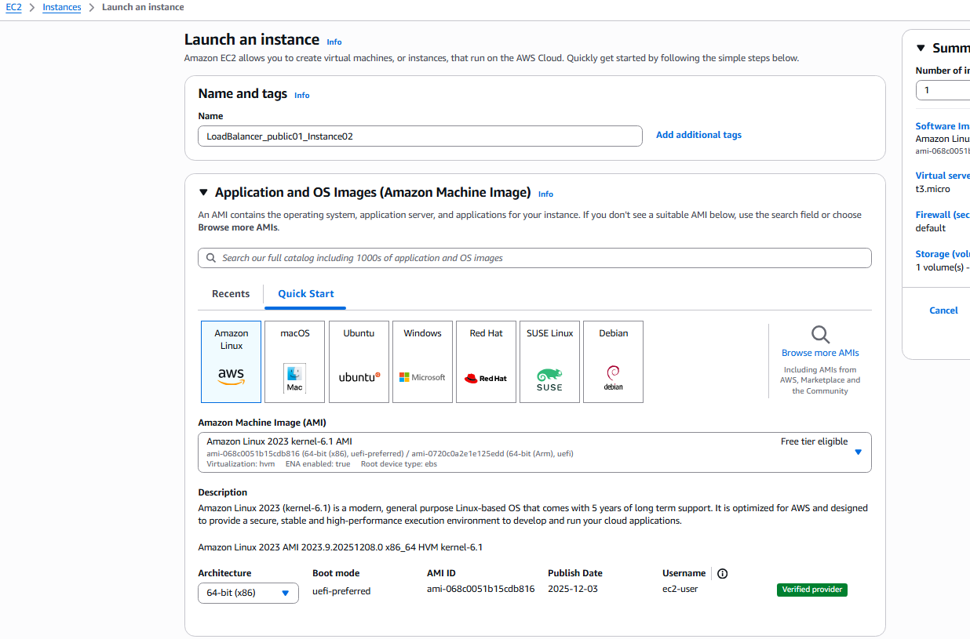

Step 12: User Data confirmation for second subnet instance
Console path / CLI command: Launch Instance → Advanced details
Explanation: Unique index.html allows identifying served responses.
Evidence: 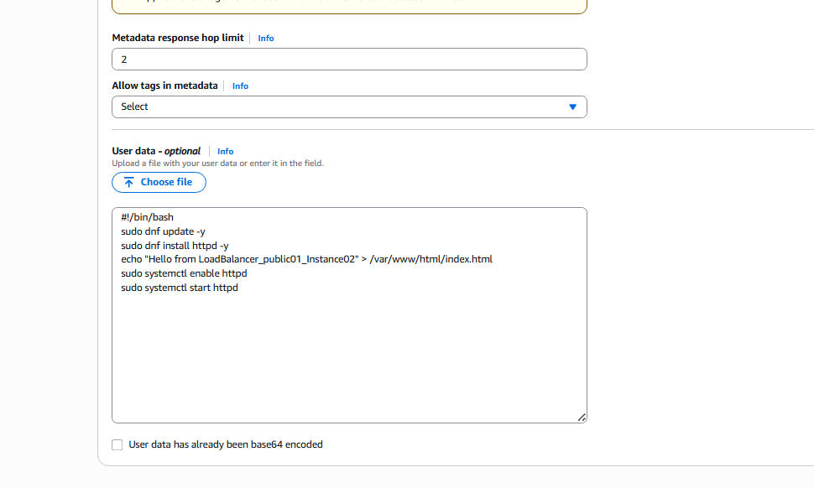

Step 13: Configure listeners, health checks, and attributes
Console path / CLI command: Classic Load Balancer → Configure Health Check
Explanation: Health check uses HTTP:80 /index.html for validation.
Evidence: Image: 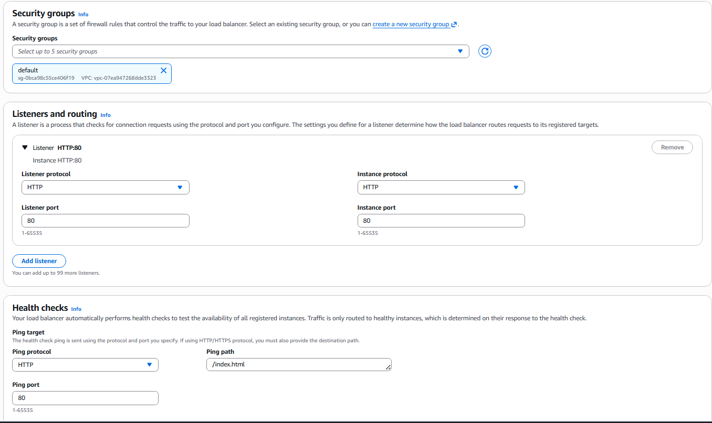

Step 14: Review and create load balancer
Console path / CLI command: CLB → Review → Create
Explanation: Finalizes configuration.
Evidence: 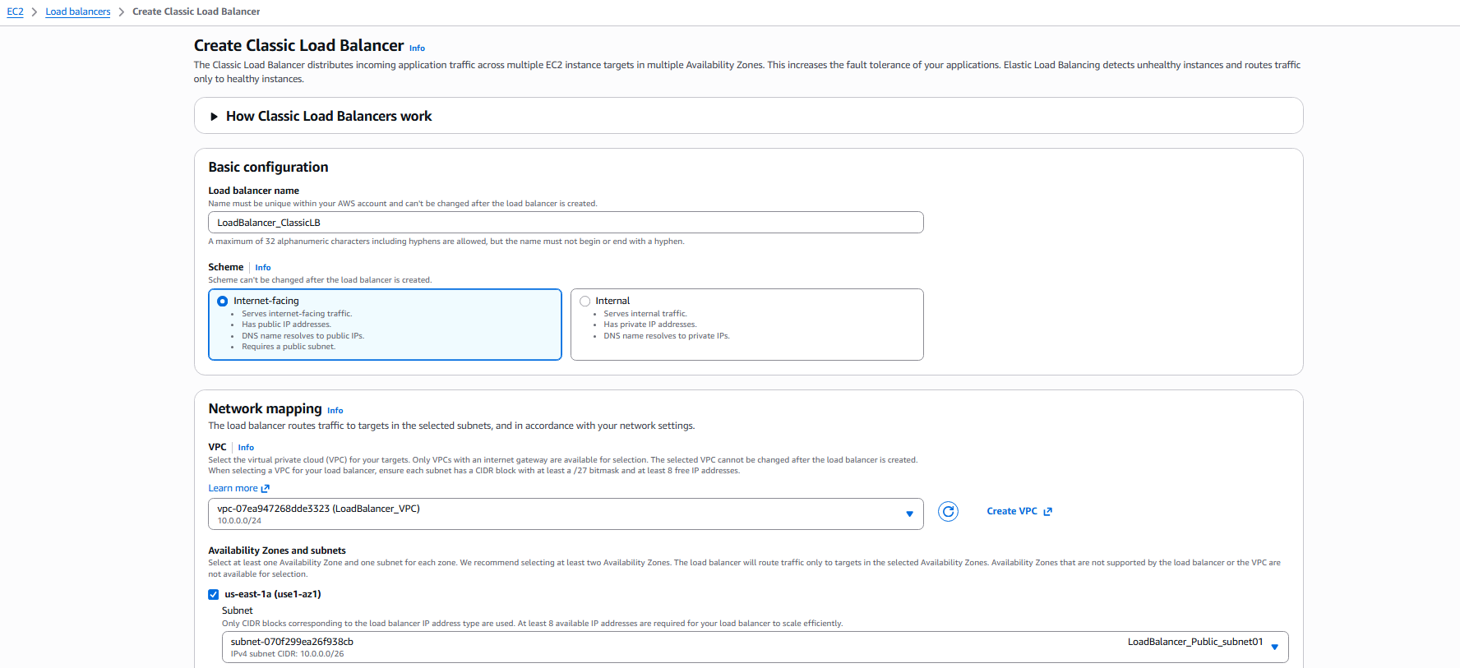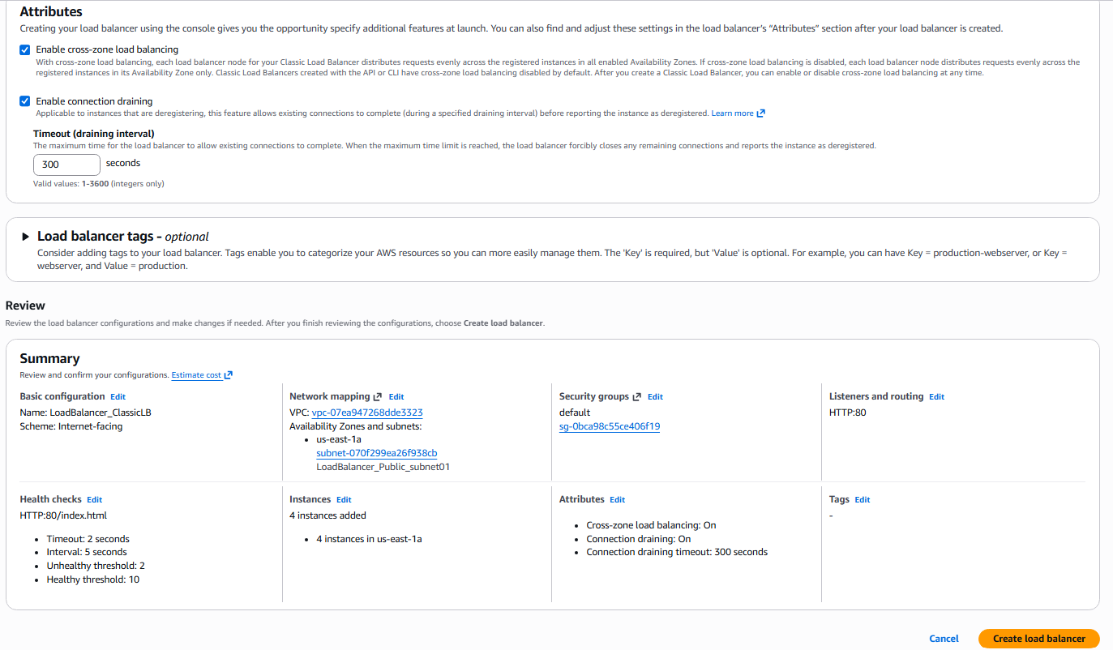

Step 15: Verify load balancer status
Console path / CLI command: EC2 → Load Balancers
Explanation: Ensures CLB is active and DNS name is available.
Evidence: 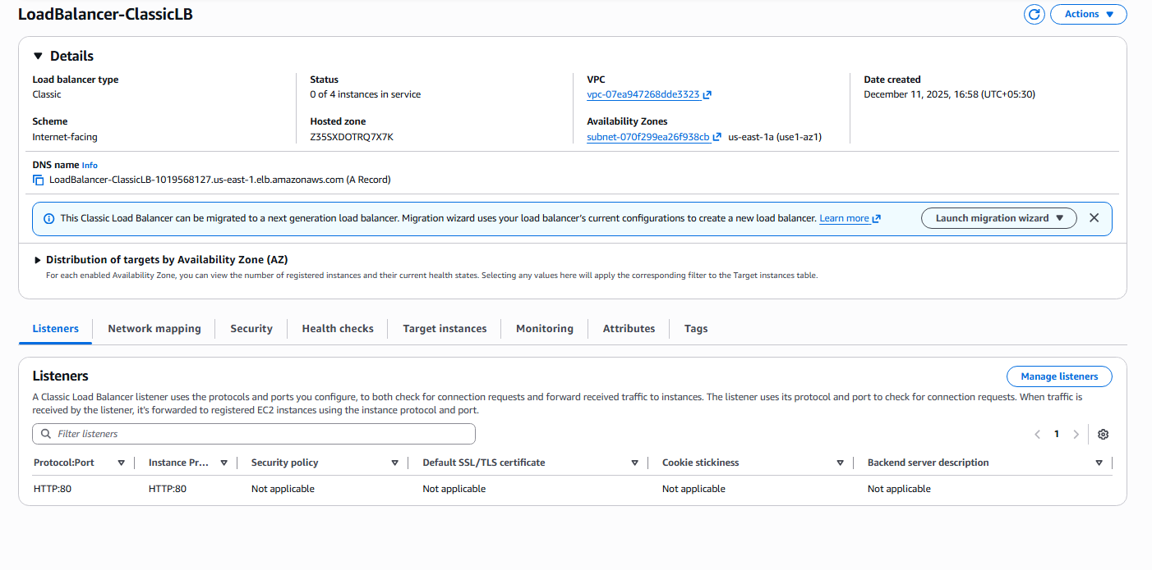

Step 16: Register EC2 instances
Console path / CLI command: CLB → Instances
Explanation: Instances transition to "InService".
Evidence: 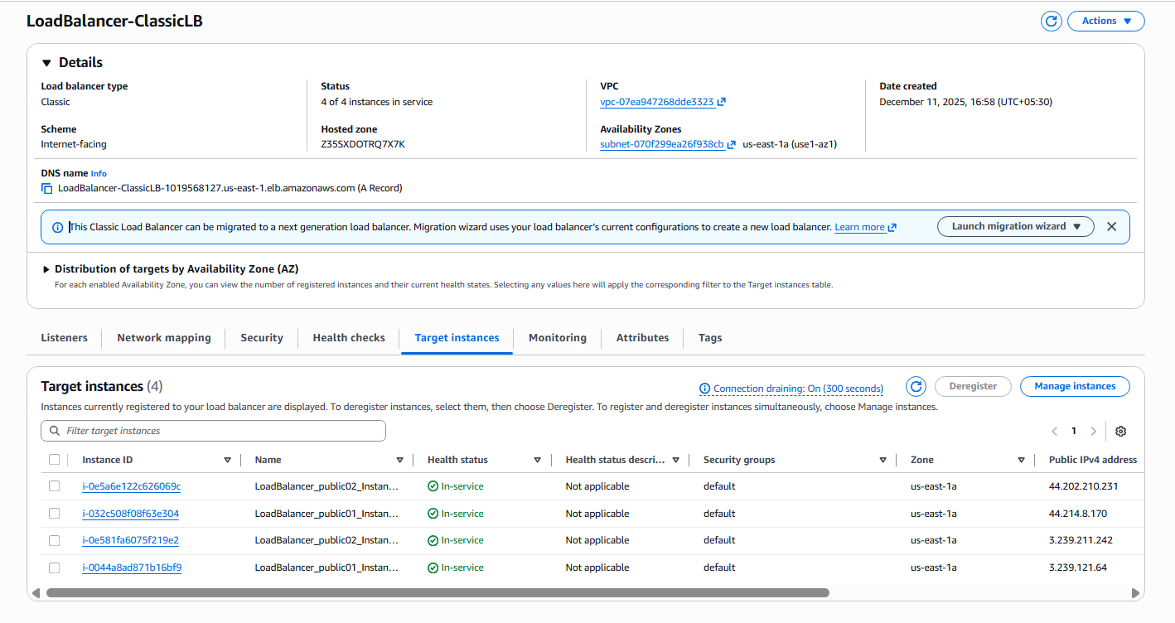

Step 17: Test load balancer DNS
Console path / CLI command: Browser → Enter CLB DNS
Explanation: Confirms requests rotate across instances.
Evidence: 

5. Validation Steps (Mandatory, With Evidence):

Validation 1: Resource Health
Example: EC2 instances show status checks passed and CLB shows "InService".
Evidence: 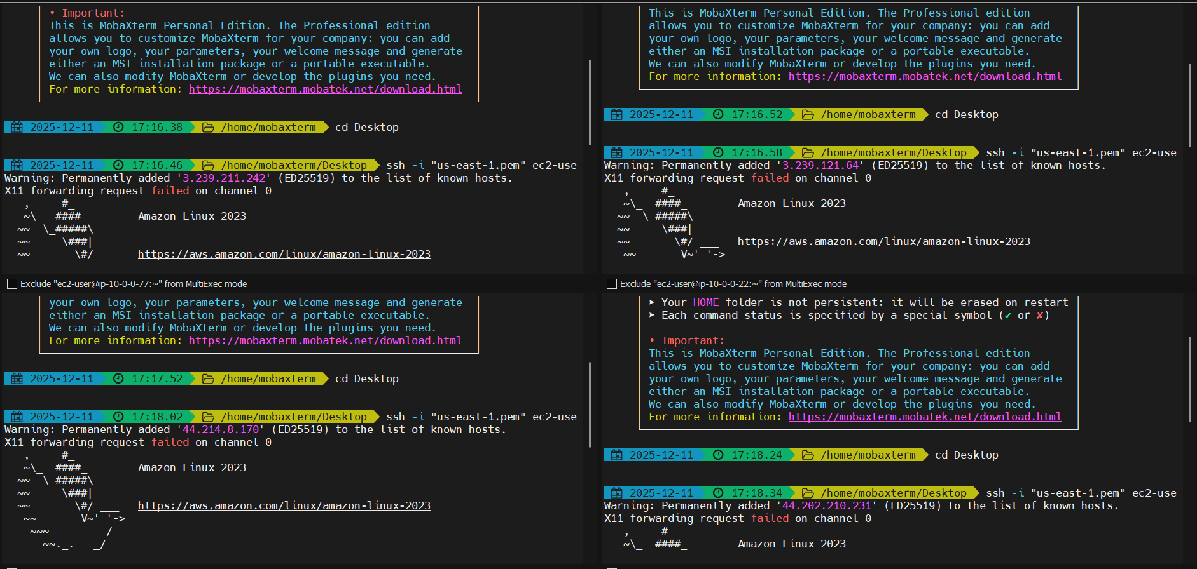

Validation 2: Functional Check
Example: Hitting CLB DNS returns different instance responses.
Evidence: 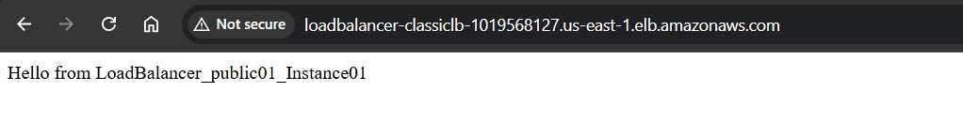
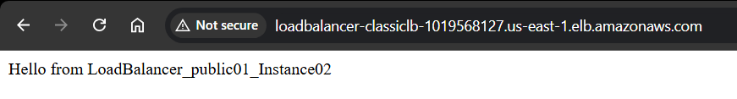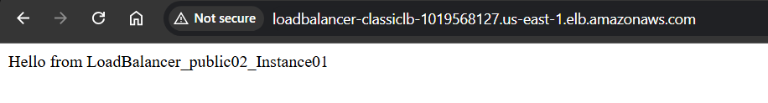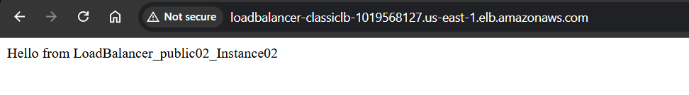
Issues Faced (Optional):
• Health check initially failed until index.html was correctly configured 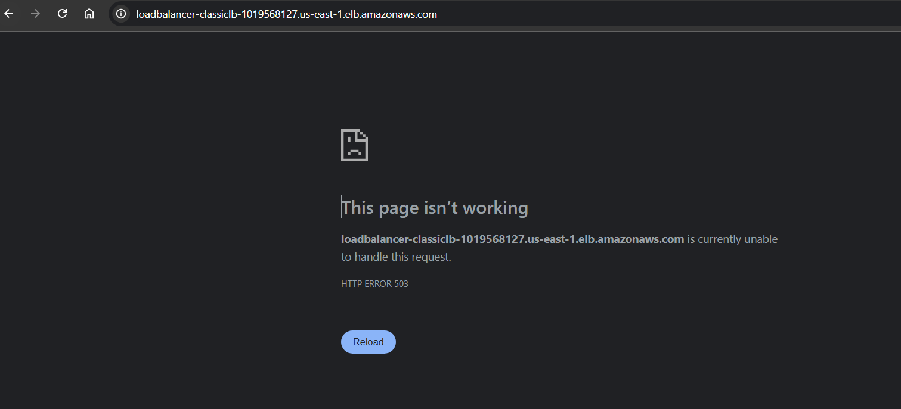
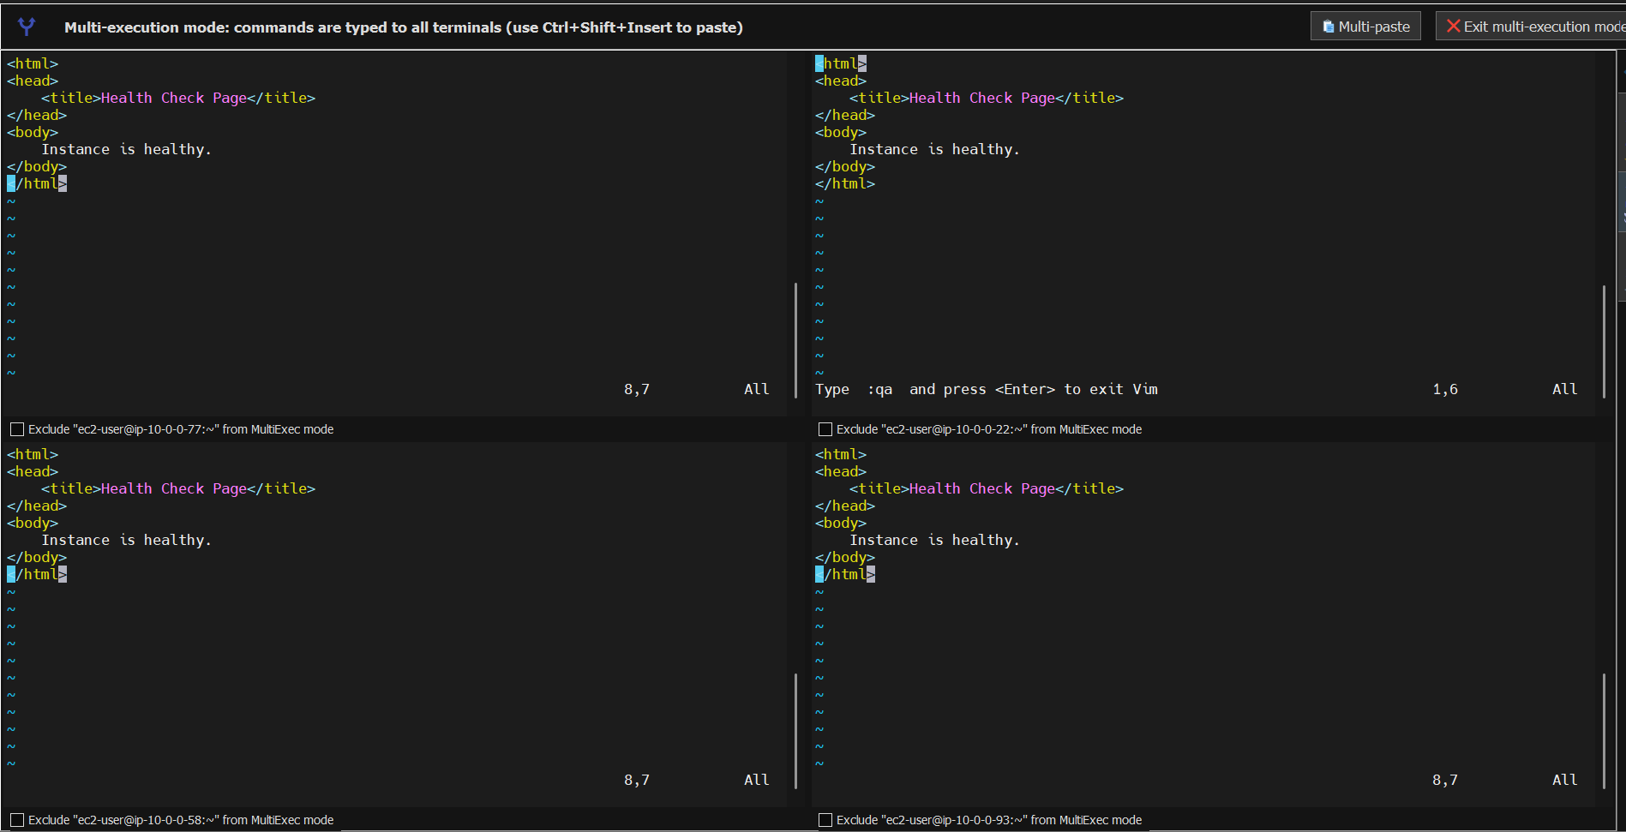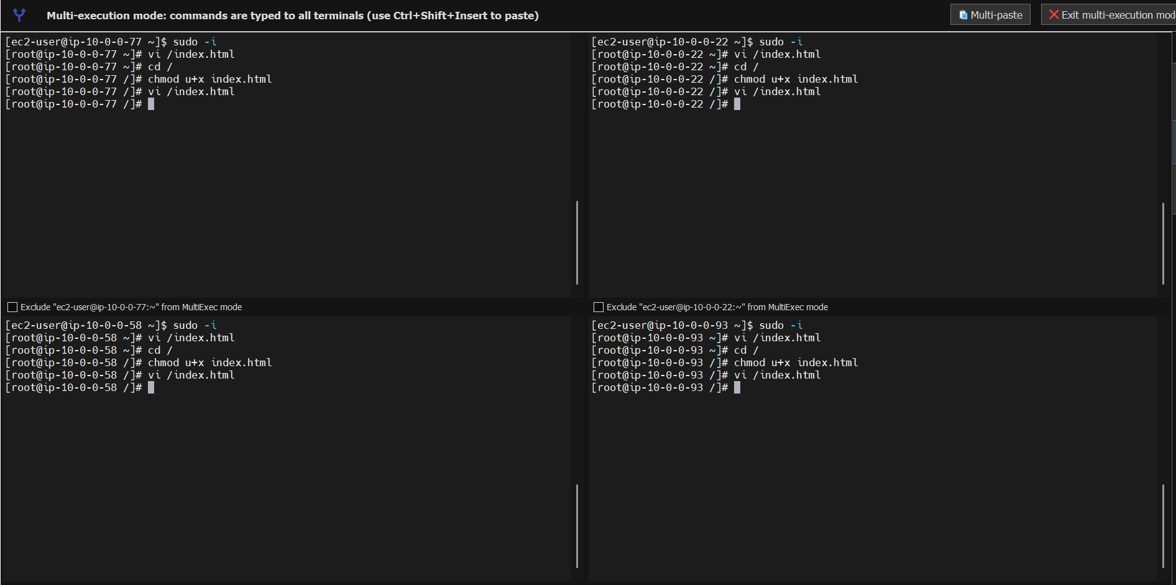
• Instances needed correct security group allowing HTTP traffic
• Delays in CLB health check stabilization

Conclusion:
The Classic Load Balancer was successfully configured and deployed across two public subnets. EC2 instances were launched with Apache and configured to serve unique index pages. All instances transitioned to a healthy state and the CLB distributed incoming traffic evenly using round-robin routing. This setup achieves high availability, load distribution, and provides a fully functional Classic Load Balancer architecture.

- Configure Application Load balancer.
- Task Title: Configure Application Load Balancer
- Objective:
To configure an Application Load Balancer (ALB) with two listeners (HTTP:80 and HTTP:81), forward traffic to two separate target groups (TG1 and TG2), register EC2 instances into each target group, and validate successful load balancing in a multi-AZ setup.
- Prerequisites:
• VPC with public subnets in us-east-1a and us-east-1b
• EC2 instances deployed in both subnets
• Security group allowing inbound HTTP traffic on ports 80 and 81
• Two target groups already created (TG1 and TG2)
•

- Step-by-Step Implementation (With Evidence):

Step 1: Create Target Group TG1
• Console path / CLI command:
EC2 Console → Load Balancing → Target Groups → Create target group
• Explanation:
TG1 is created to register instances in subnet01 and forward traffic on port 80.
Evidence: 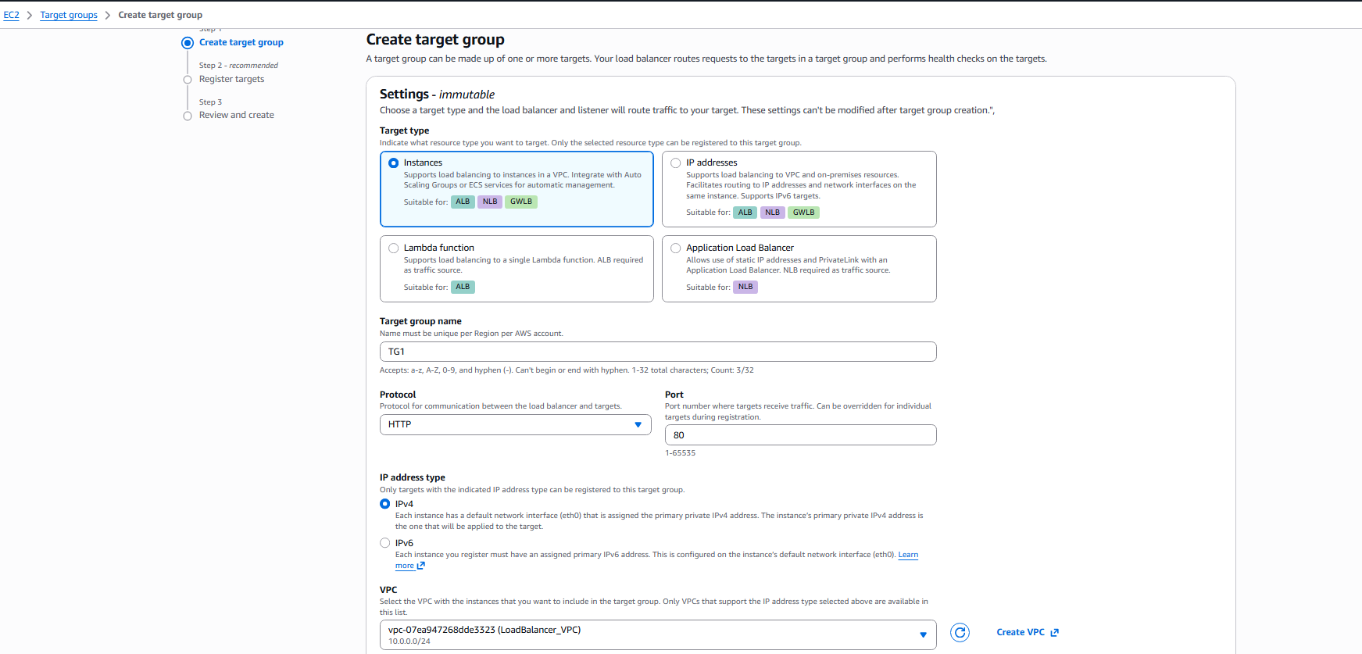

Step 2: Configure Health Checks for TG1
• Console path / CLI command:
Target Group → Health Checks → Configure HTTP path
• Explanation:
Health check protocol HTTP and path “/healthcheck.html” are configured.
Evidence: 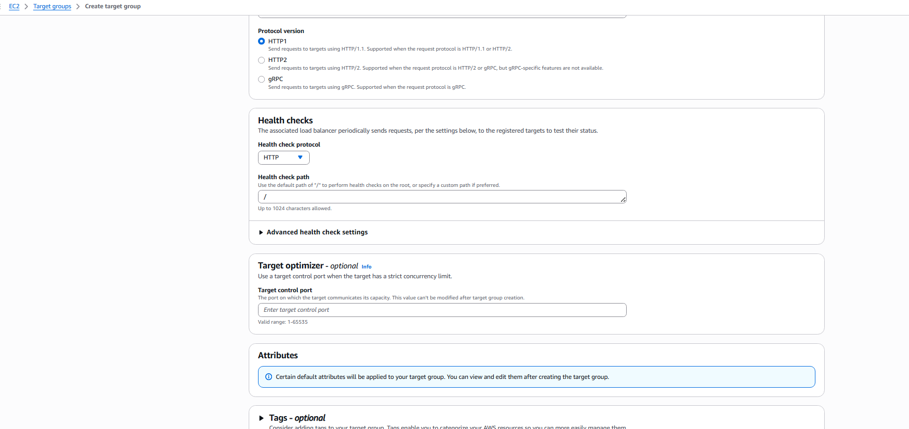

Step 3: Register Instances in TG1
• Console path / CLI command:
Target Group → Register targets → Select instances → Add pending
• Explanation:
Two EC2 instances in subnet01 are registered to TG1 on port 80.
Evidence: 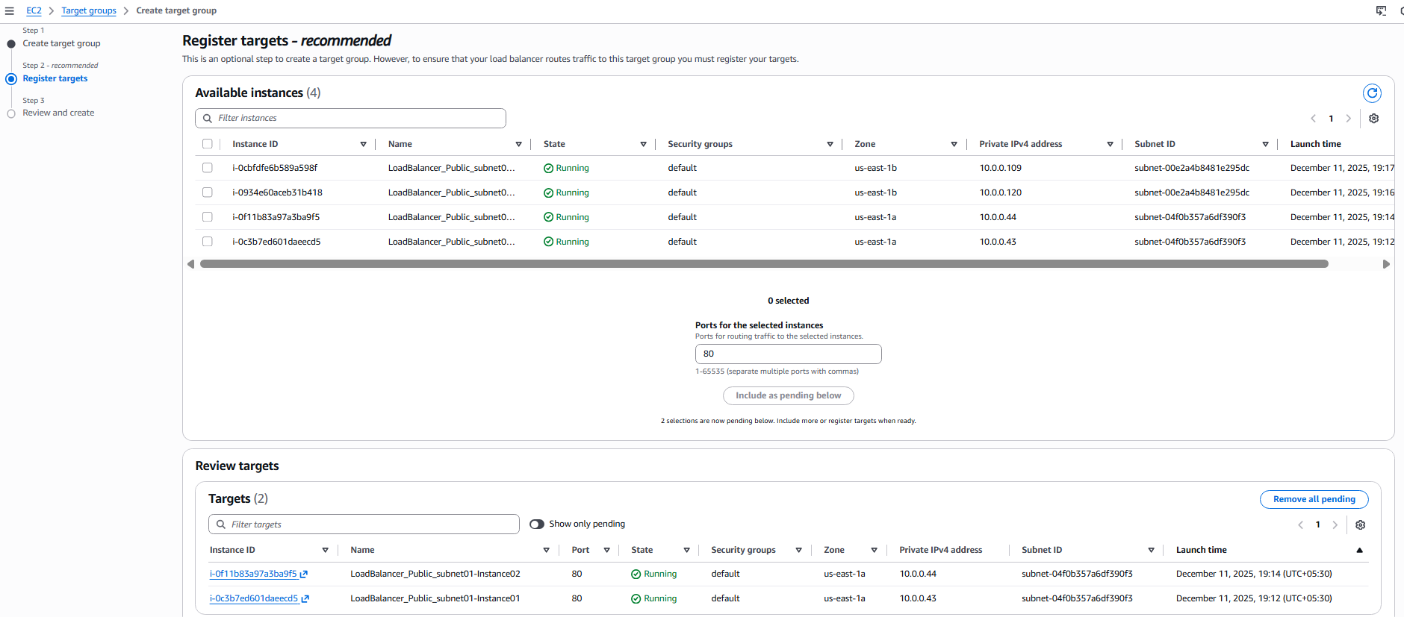

Step 4: Review and Create TG1
• Console path / CLI command:
Target Group → Review and Create
• Explanation:
Review TG1 configuration and complete target group creation.
Evidence: 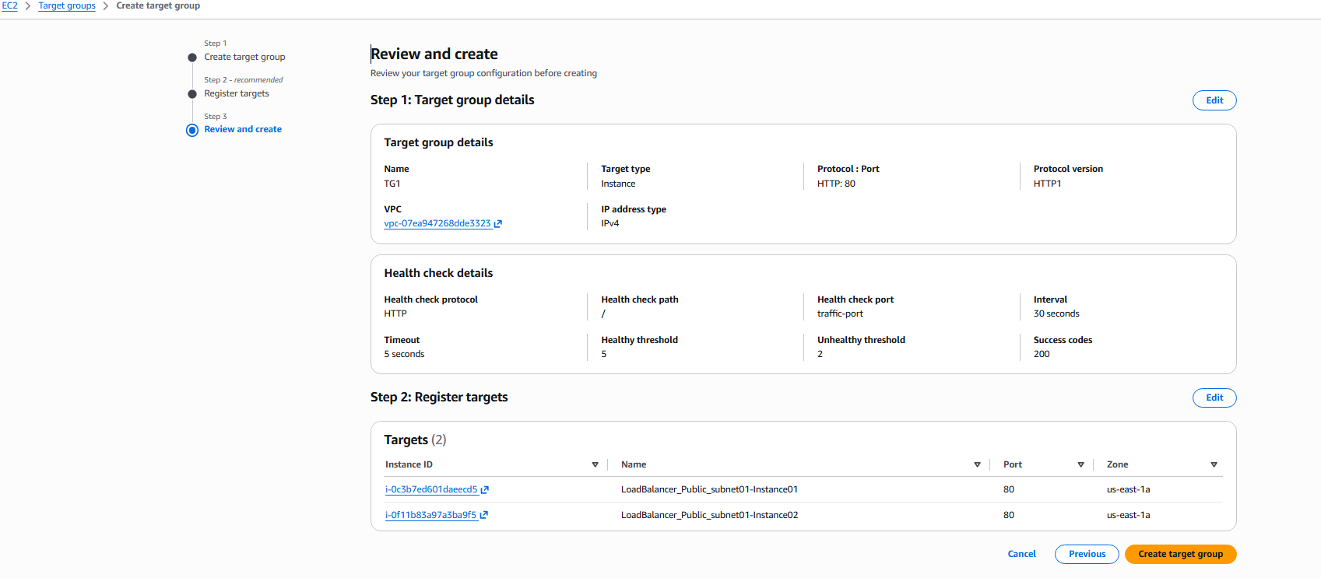

Step 5: Create Target Group TG2
• Console path / CLI command:
EC2 → Load Balancing → Target Groups → Create target group
• Explanation:
TG2 is created for instances in subnet02, also on port 80.
Evidence: 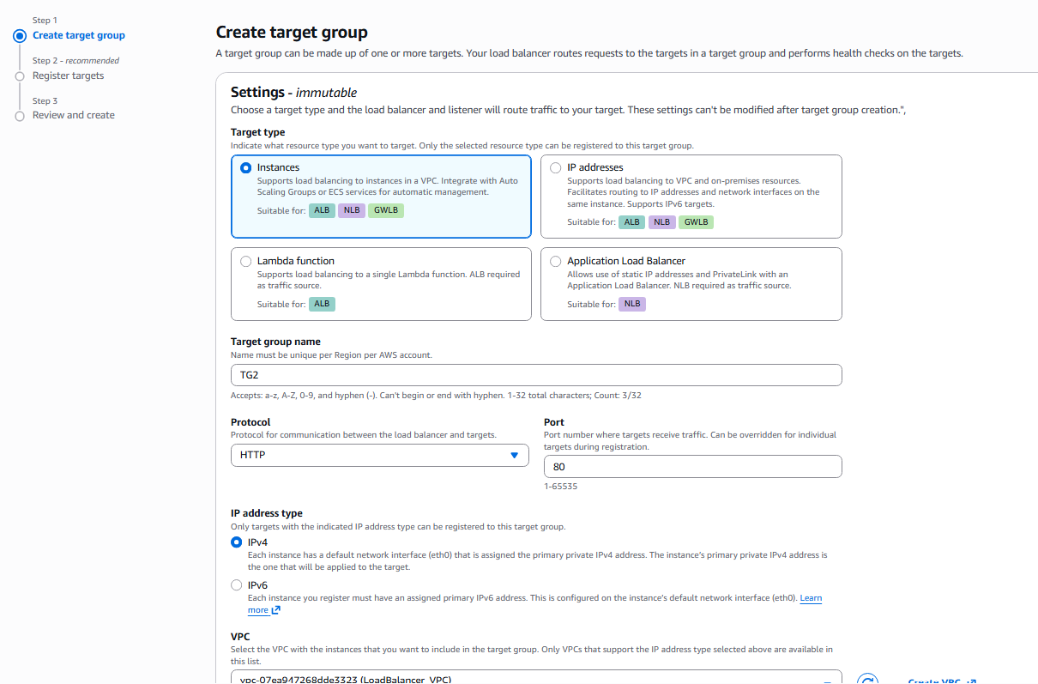

Step 6: Configure TG2 Health Checks
• Console path / CLI command:
Target Group → Health Checks
• Explanation:
HTTP health check configured with custom path “/index.html”.
Evidence: 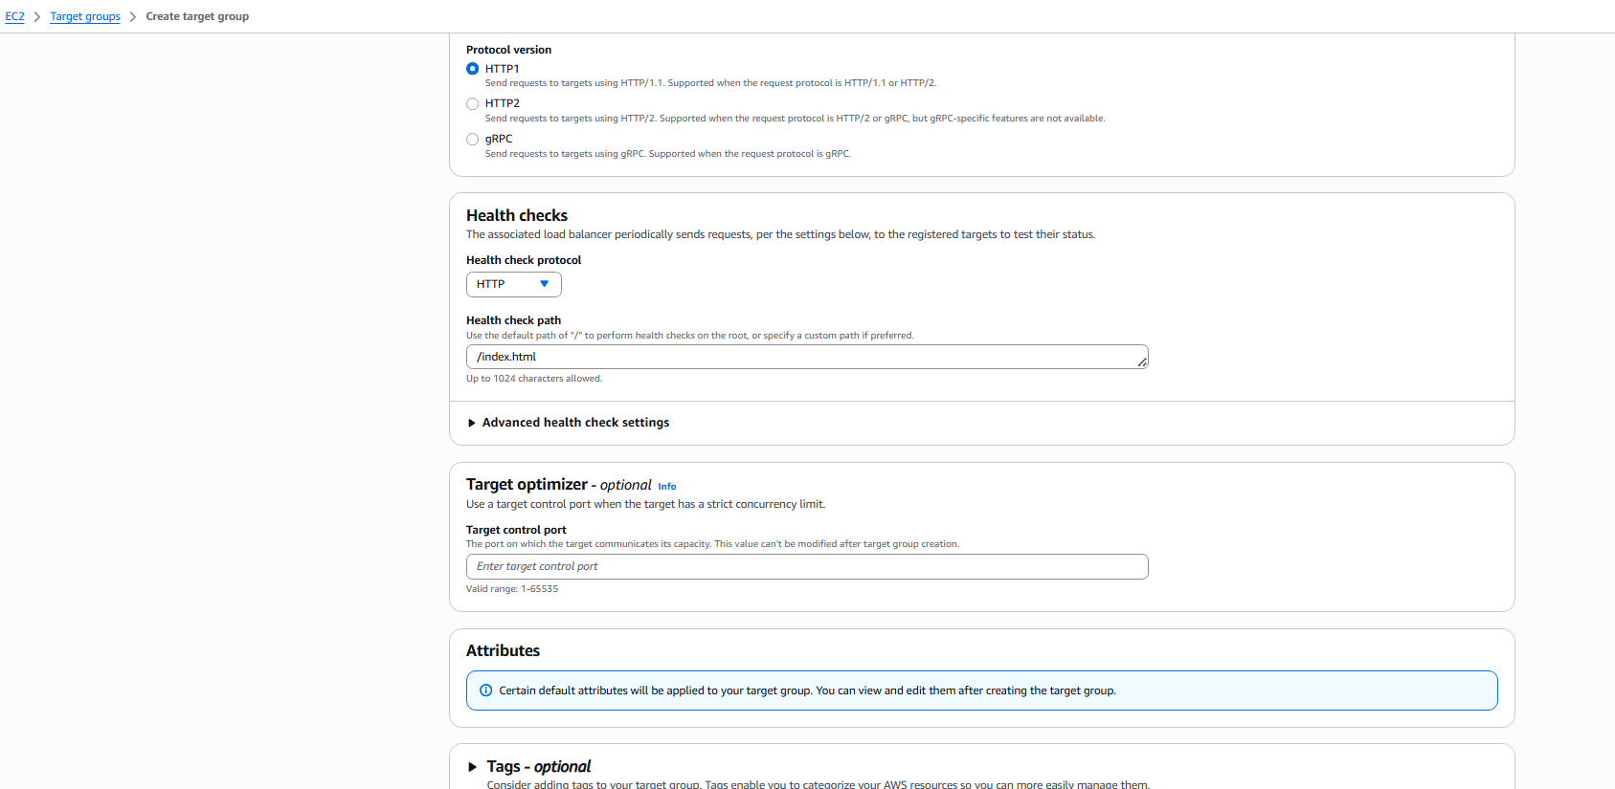

Step 7: Register Instances in TG2
• Console path / CLI command:
Target Group → Register targets
• Explanation:
Two EC2 instances from subnet02 are registered.
Evidence: 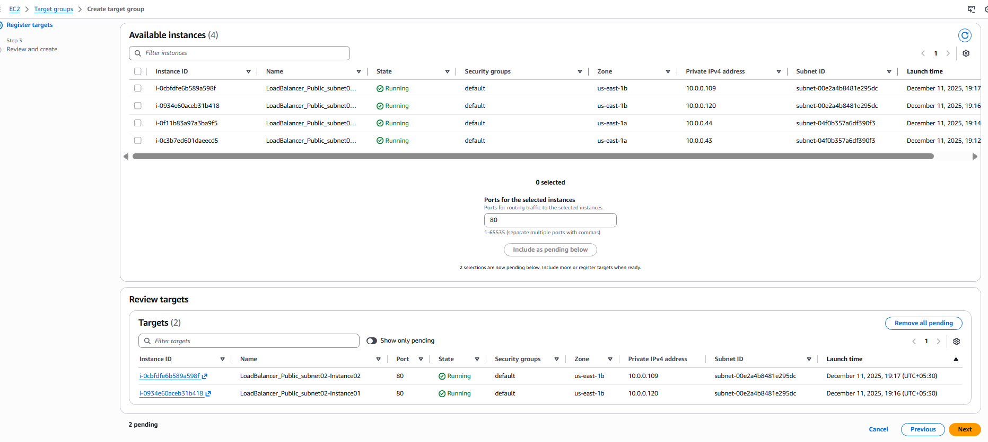

Step 8: Review and Create TG2
• Console path / CLI command:
Target Group → Review and Create
• Explanation:
Confirm TG2 details and complete creation.
Evidence: 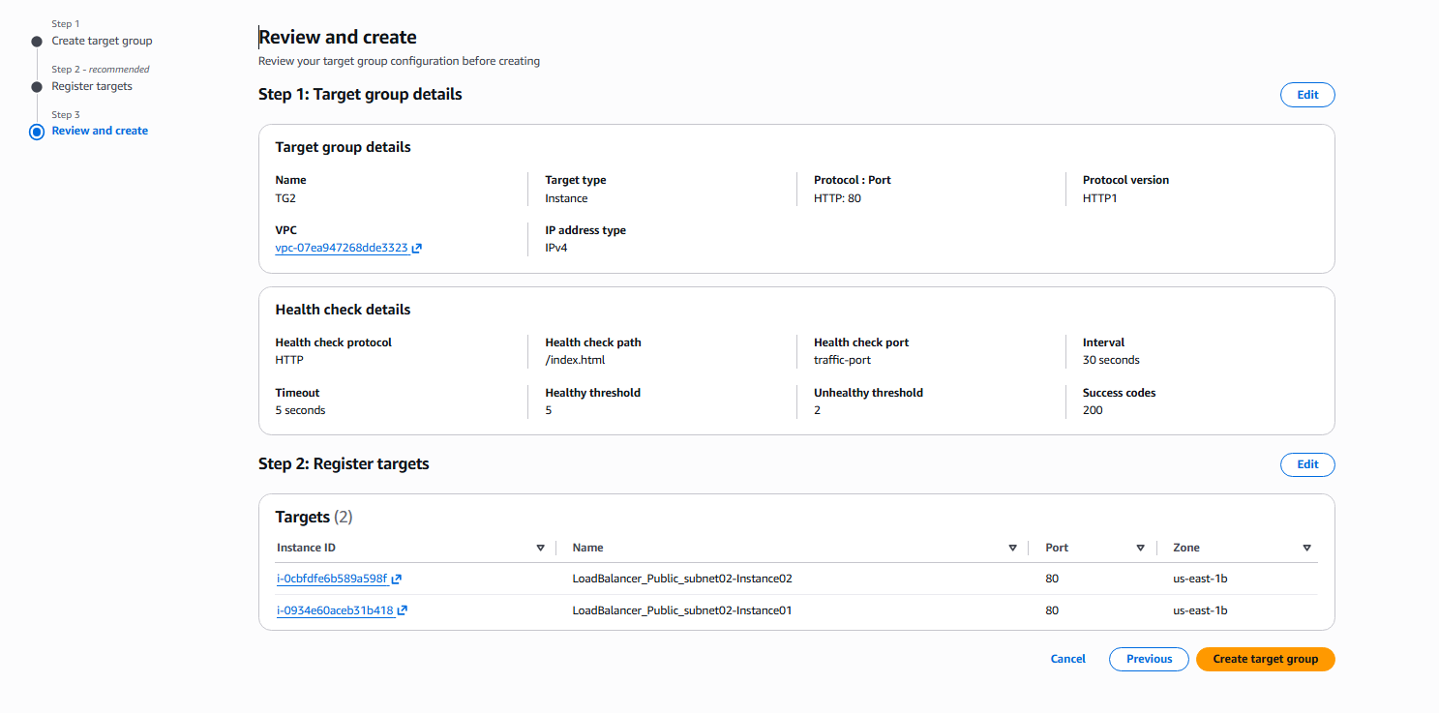

Step 9: Verify Both Target Groups
• Console path / CLI command:
Target Groups dashboard
• Explanation:
Ensure TG1 and TG2 exist with the correct configuration.
Evidence: 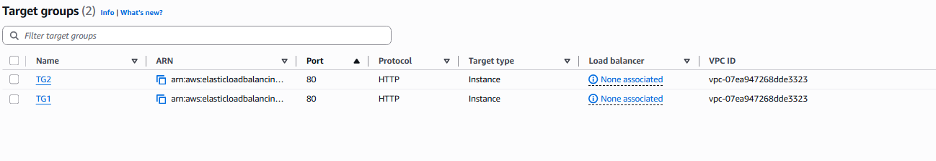

Step 10: Create Application Load Balancer
• Console path / CLI command:
EC2 → Load Balancers → Create Load Balancer → Application Load Balancer
• Explanation:
ALB is configured with internet-facing scheme and IPv4 address type.
Evidence: 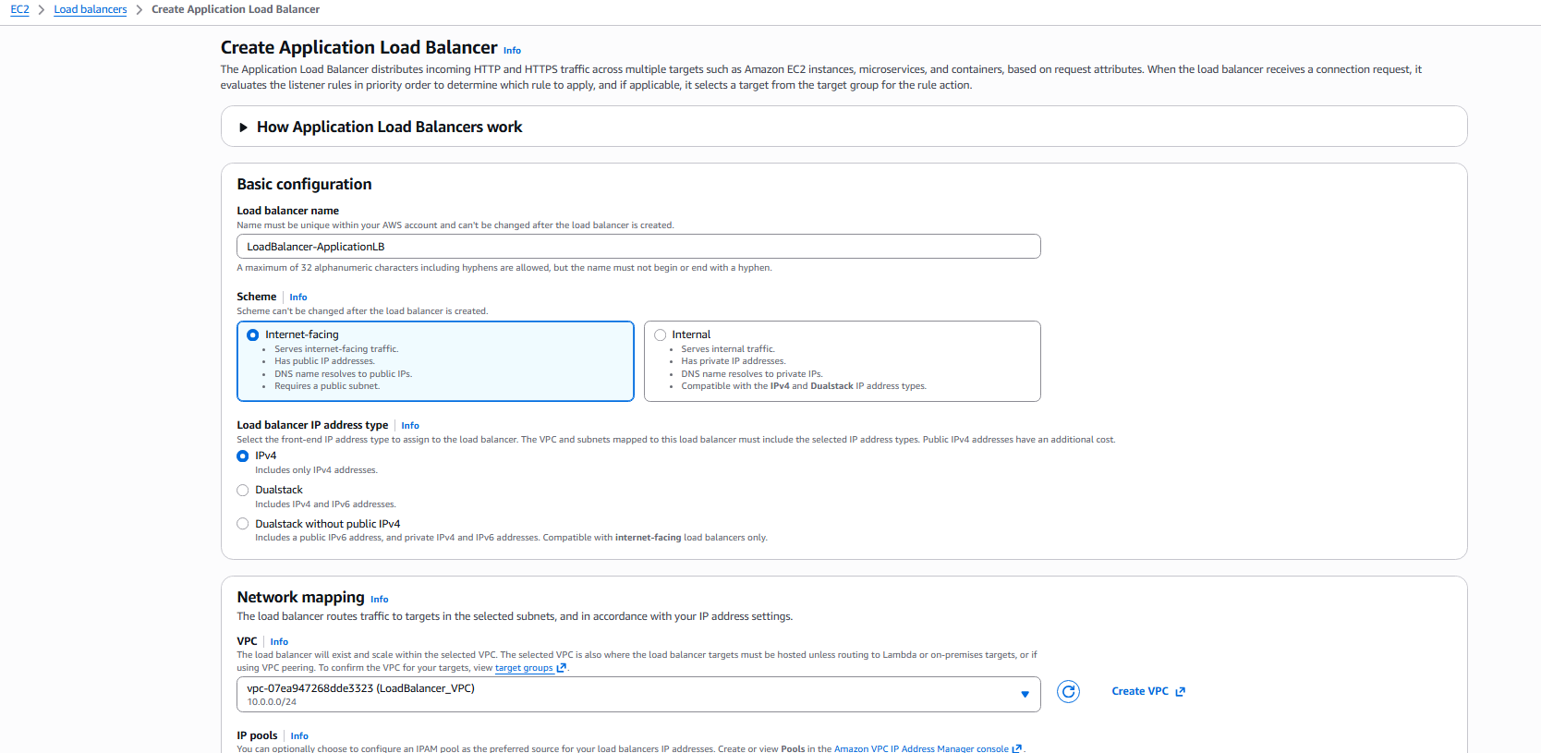

Step 11: Choose Availability Zones and Subnets
• Console path / CLI command:
Load Balancer → Availability Zones
• Explanation:
Subnets us-east-1a and us-east-1b are selected to ensure HA.
Evidence: 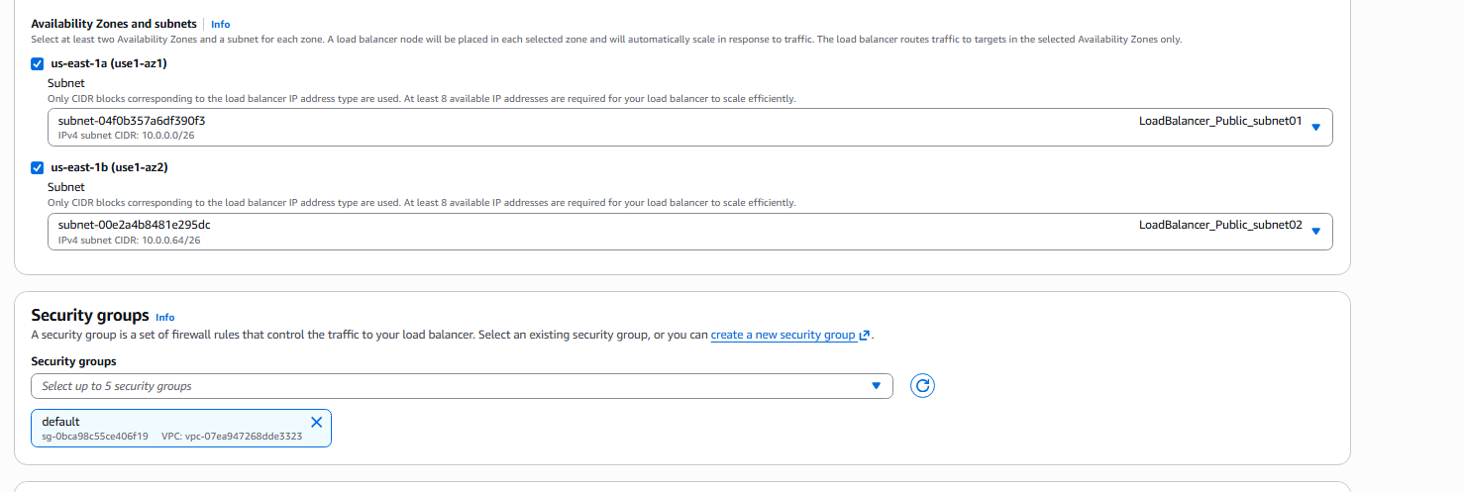

Step 12: Configure Listener for Port 80
• Console path / CLI command:
Load Balancer → Listeners → Add listener
• Explanation:
Listener on port 80 forwards traffic to TG1.
Evidence: 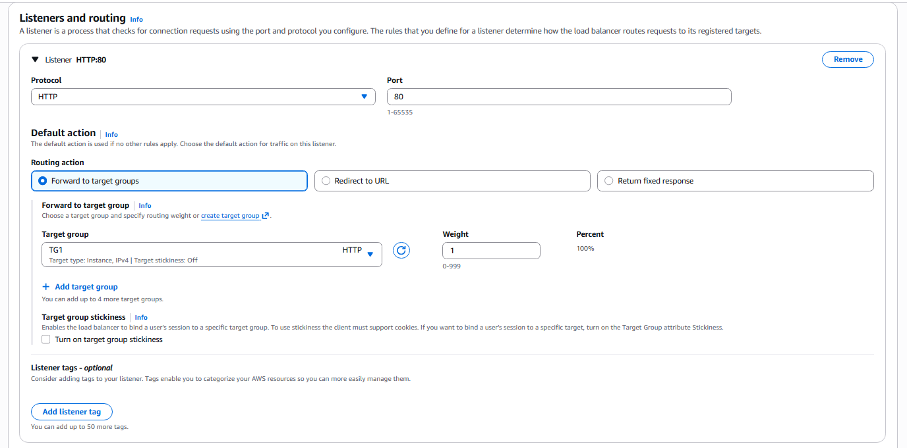

Step 13: Configure Listener for Port 81
• Console path / CLI command:
Load Balancer → Listeners → Add Listener (port 81)
• Explanation:
Listener for port 81 forwards traffic to TG2.
Evidence: 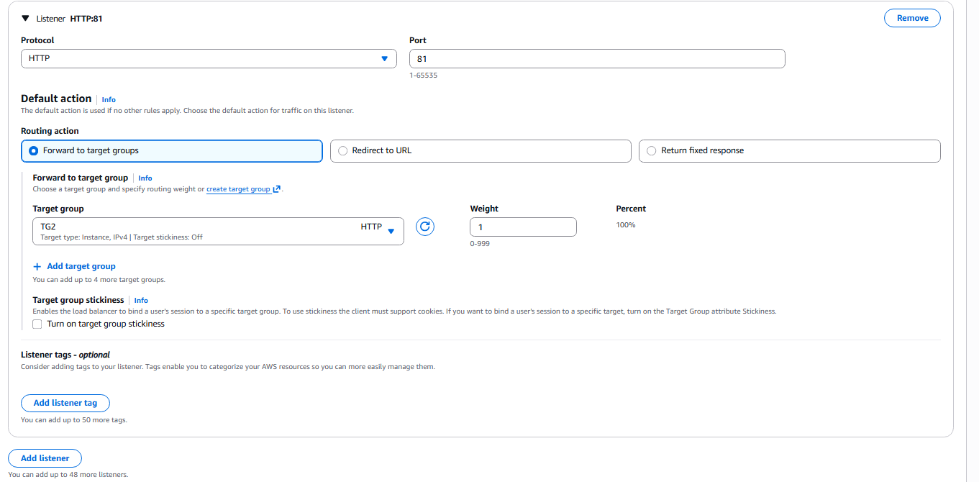

Step 14: Review ALB Configuration
• Console path / CLI command:
Load Balancers → Review
• Explanation:
Review all settings before creating the ALB.
Evidence: 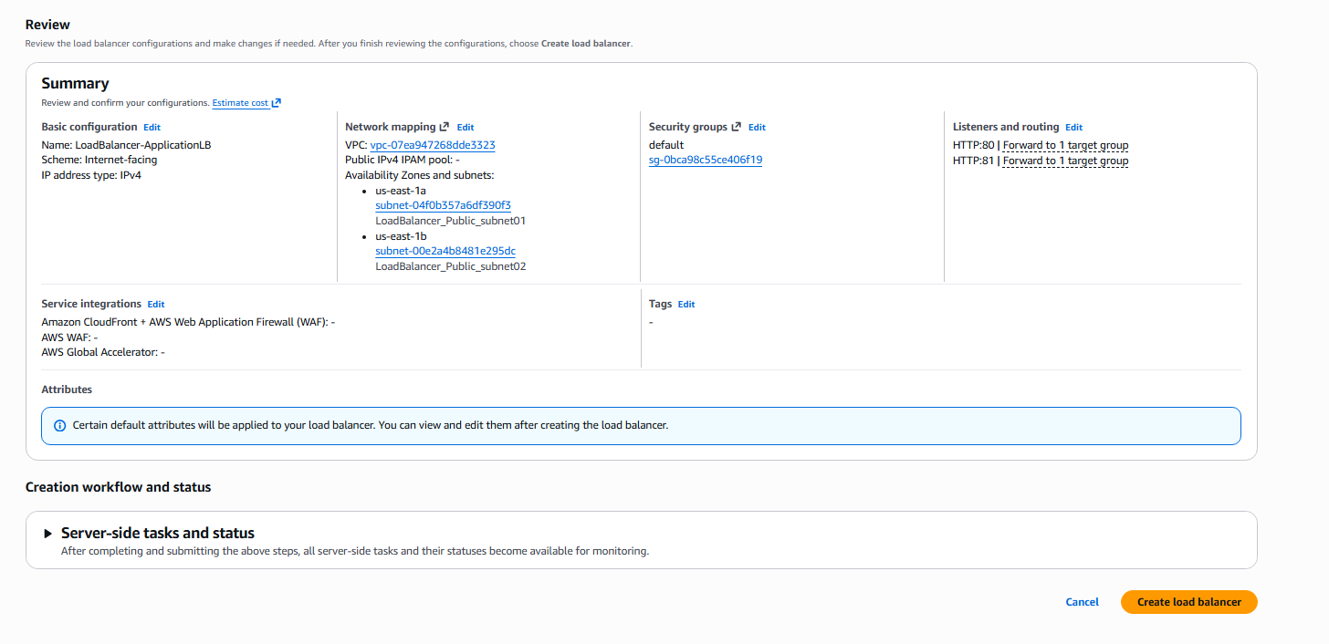

Step 15: Verify Registered Targets for TG1
• Console path / CLI command:
Target Groups → TG1 → Targets
• Explanation:
Ensure both subnet01 instances are healthy.
Evidence: 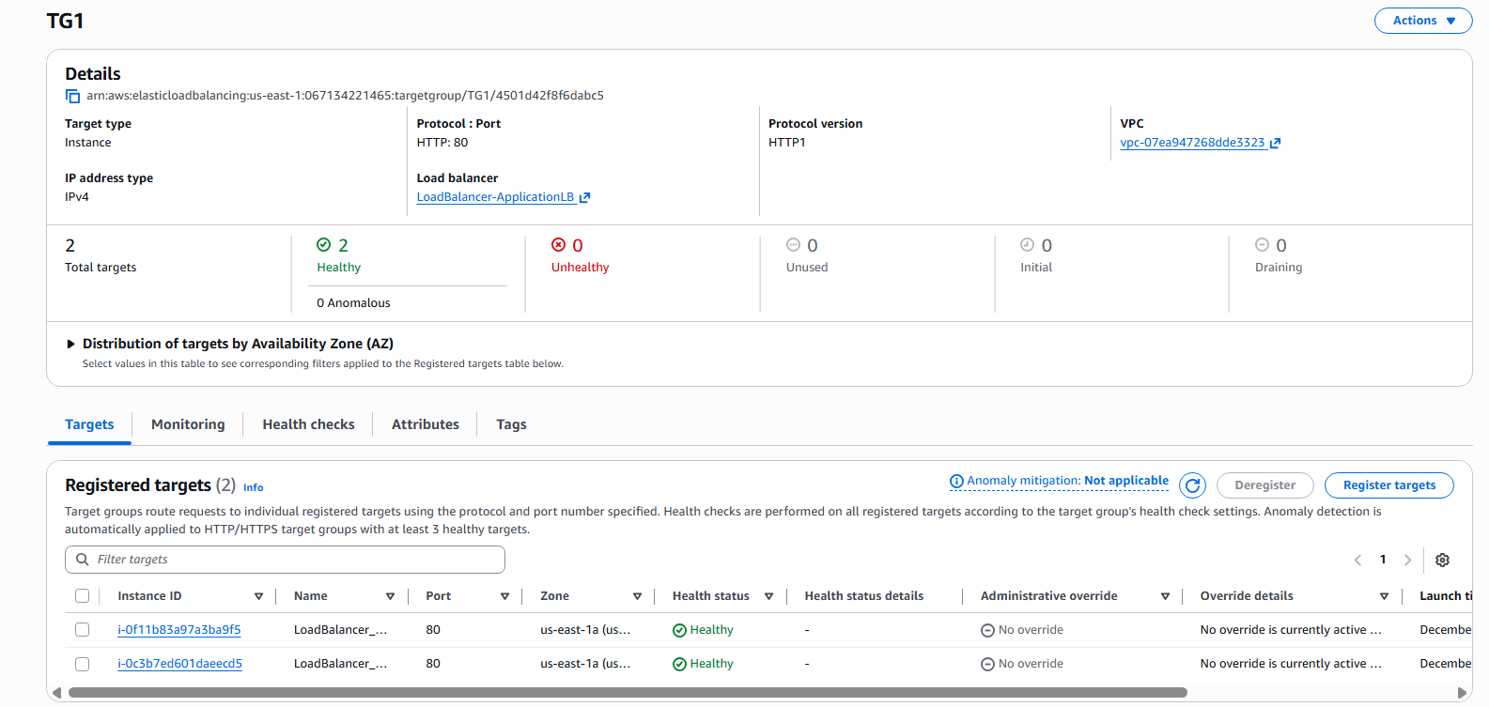

Step 16: Verify Registered Targets for TG2
• Console path / CLI command:
Target Groups → TG2 → Targets
• Explanation:
Ensure both subnet02 instances are healthy.
Evidence: 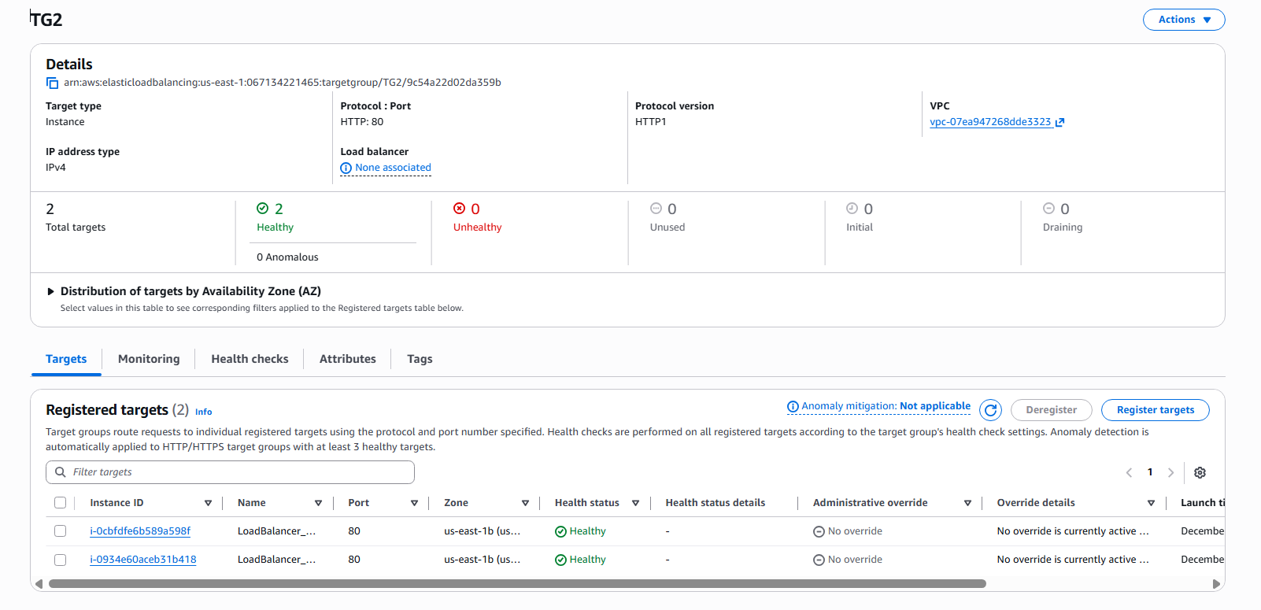

Step 17: Validate ALB Deployment
• Console path / CLI command:
Load Balancers → Select ALB
• Explanation:
Check that ALB is active with both listeners configured.
Evidence: 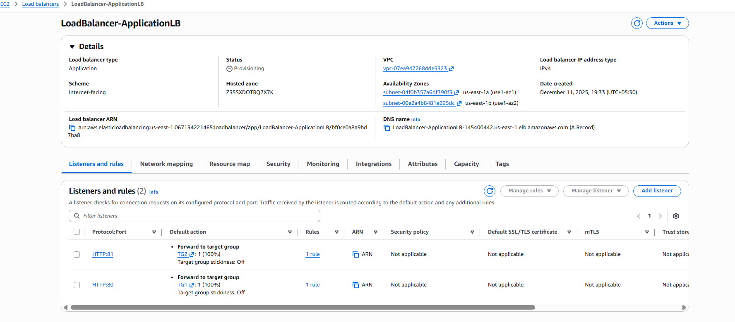
Validation Steps (Mandatory, With Evidence):

Step 1: Test TG1 via ALB Listener Port 80
• Console path / CLI command:
Access ALB DNS Name via browser http://ALB-DNS

• Explanation:
Traffic alternates between TG1 instances.
Evidence: 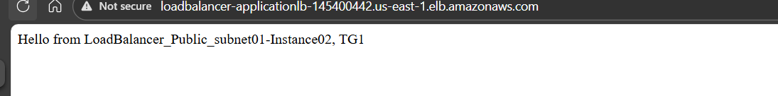

Step 2: Test TG1 Instance 2 Response
• Console path / CLI command:
Refresh browser
• Explanation:
Shows second instance response.
Evidence: 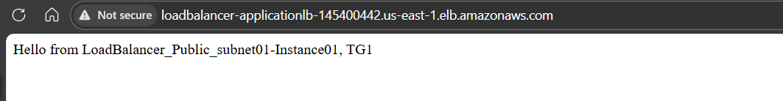

Step 3: Test TG2 via Listener Port 81
• Console path / CLI command:
http://ALB-DNS:81

• Explanation:
Returns response from TG2 instance.
Evidence: 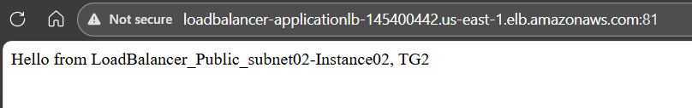
Step 4: Test TG2 via Listener Port 81

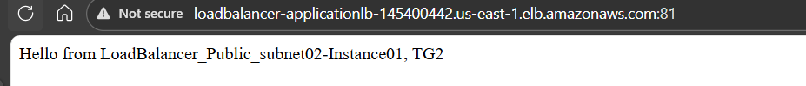

Issues Faced (Optional):
Initially I have only configured the subnets in the same available zone and later on I have changed the subnets in the different available zones and provisioned the instances accordingly. I have also configured the healthcheck.html file in the / folder to enable the health check during the load balancer configuration.

Conclusion:
The Application Load Balancer was successfully configured with two listeners and two target groups. Instances in both subnets were registered correctly, health checks passed, and the ALB served traffic as expected on ports 80 and 81. The configuration achieved high availability and proper load distribution across all instances.

- Configure Network Load balancer.
  - Task Title:
Configure Network Load Balancer (NLB)

  - Objective:
Set up an Internet-facing Network Load Balancer with two listeners (TCP:80 and TCP:81), forwarding traffic to two separate target groups (NLN-TG1 and NLN-TG2), each containing EC2 instances in different subnets. Validate traffic distribution, target health, and connectivity.
  - Prerequisites:
• VPC with at least two public subnets
• Four EC2 instances running web servers on port 80
• NLB target groups NLN-TG1 and NLN-TG2 created with health check path
• Security group allowing inbound TCP 80 and 81
• Basic HTML test pages deployed on instances
4. Step-by-Step Implementation (With Evidence):

Step 1: Create Target Group NLN-TG1
Console path: EC2 Console > Load Balancing > Target Groups > Create Target Group
Explanation: Create the first target group that will receive traffic from Listener TCP:80.
Evidence: 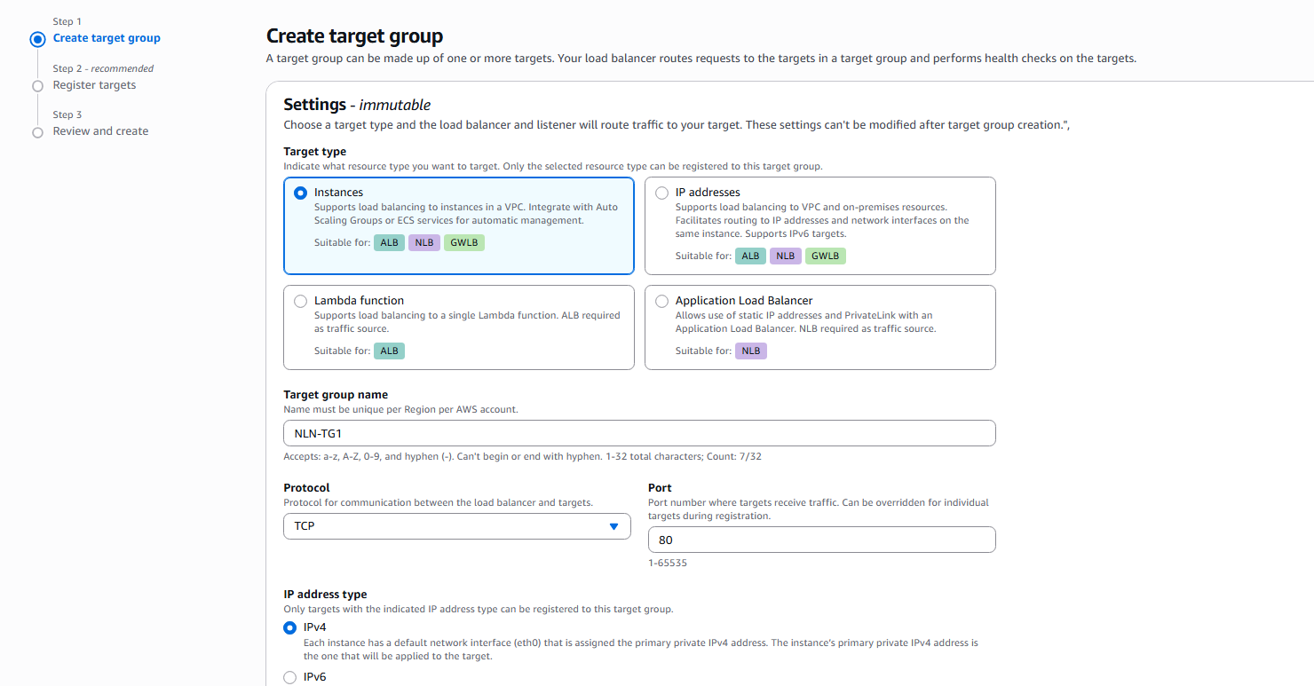 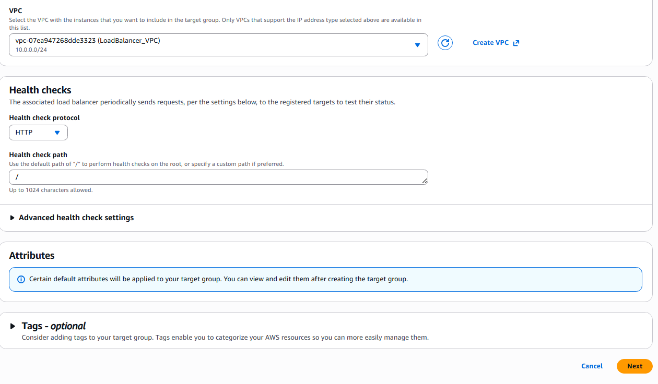 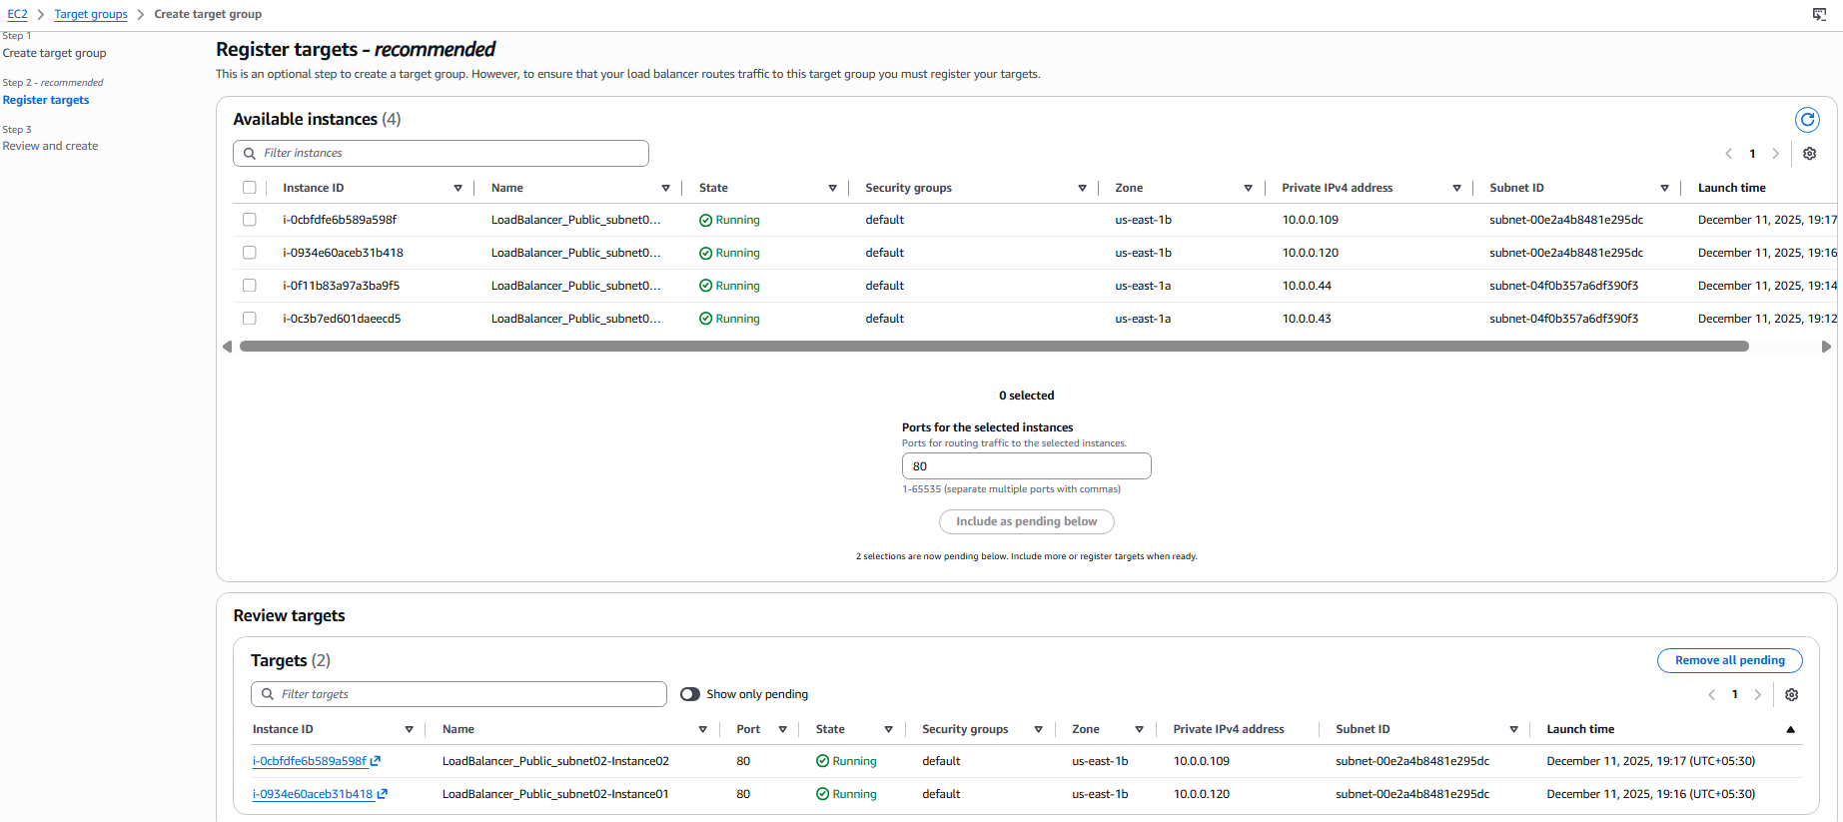 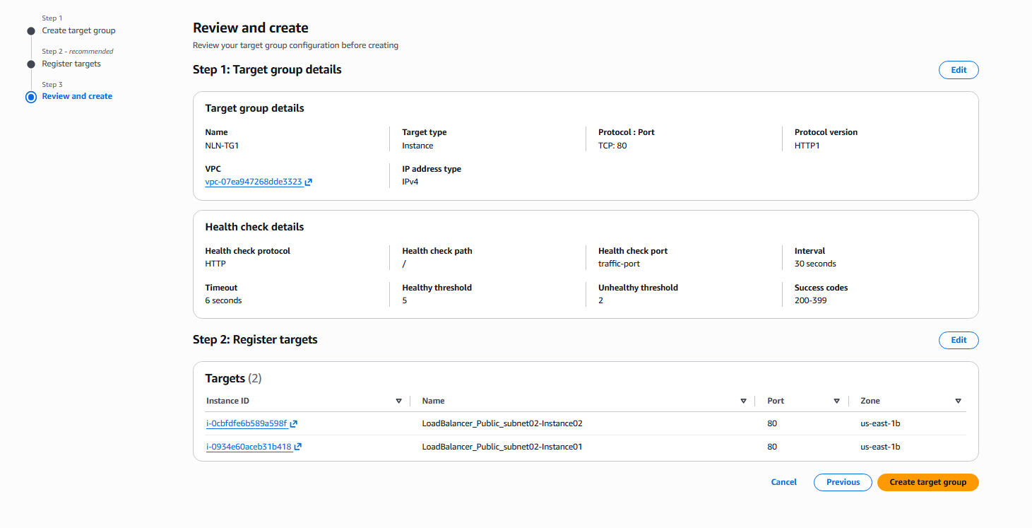

Step 2: Create Target Group NLN-TG2
Console path: EC2 Console > Load Balancing > Target Groups > Create Target Group
Explanation: Create the second target group that will receive traffic from Listener TCP:81.
Evidence: 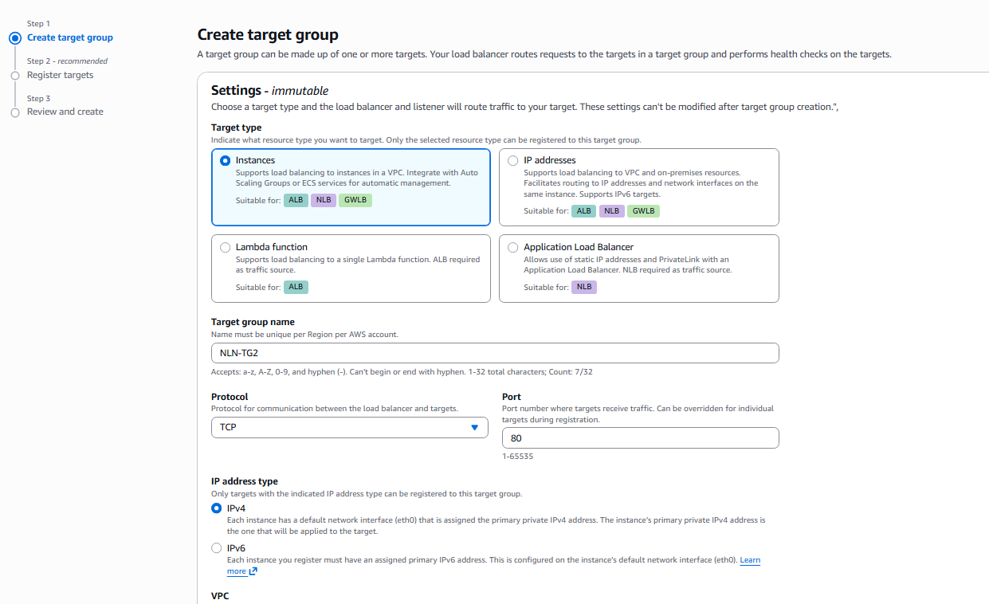 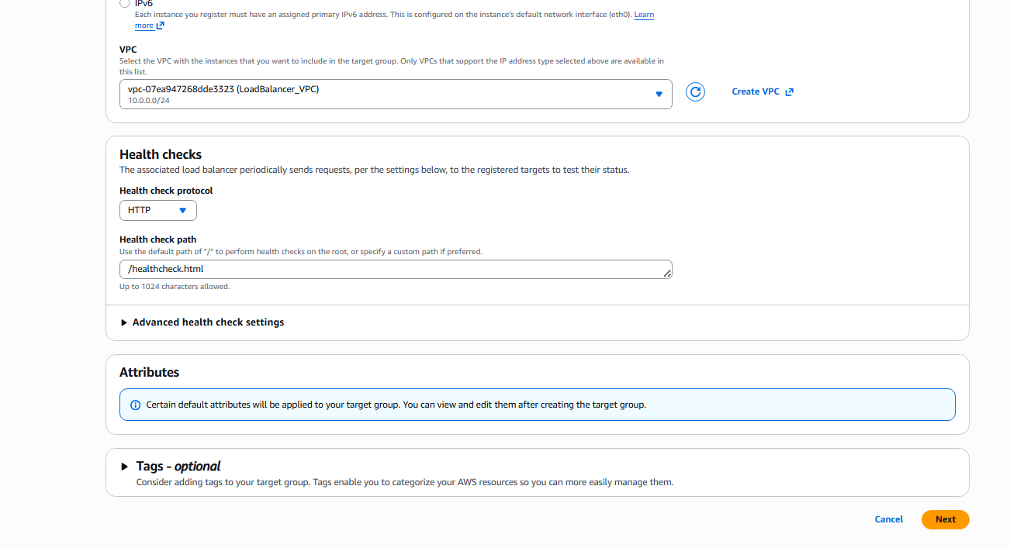 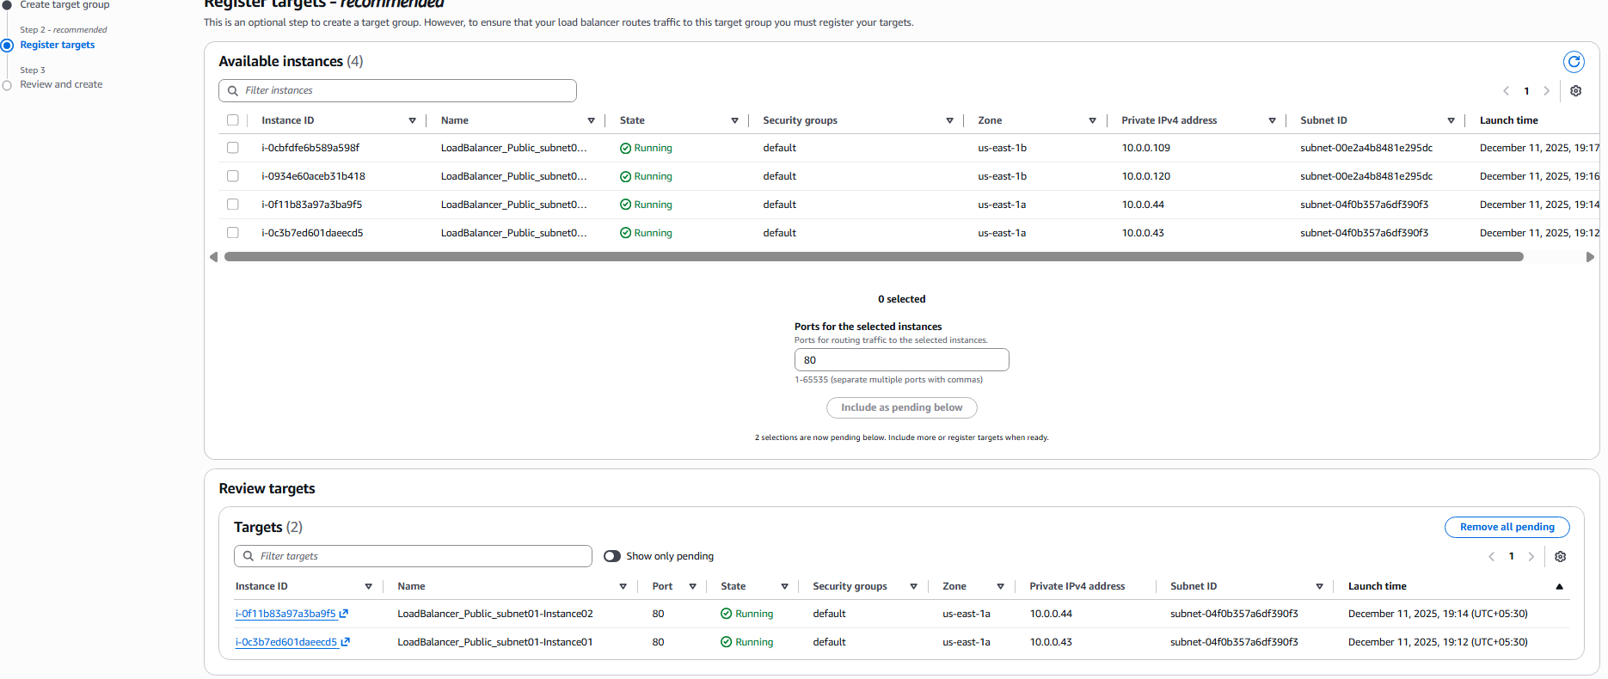 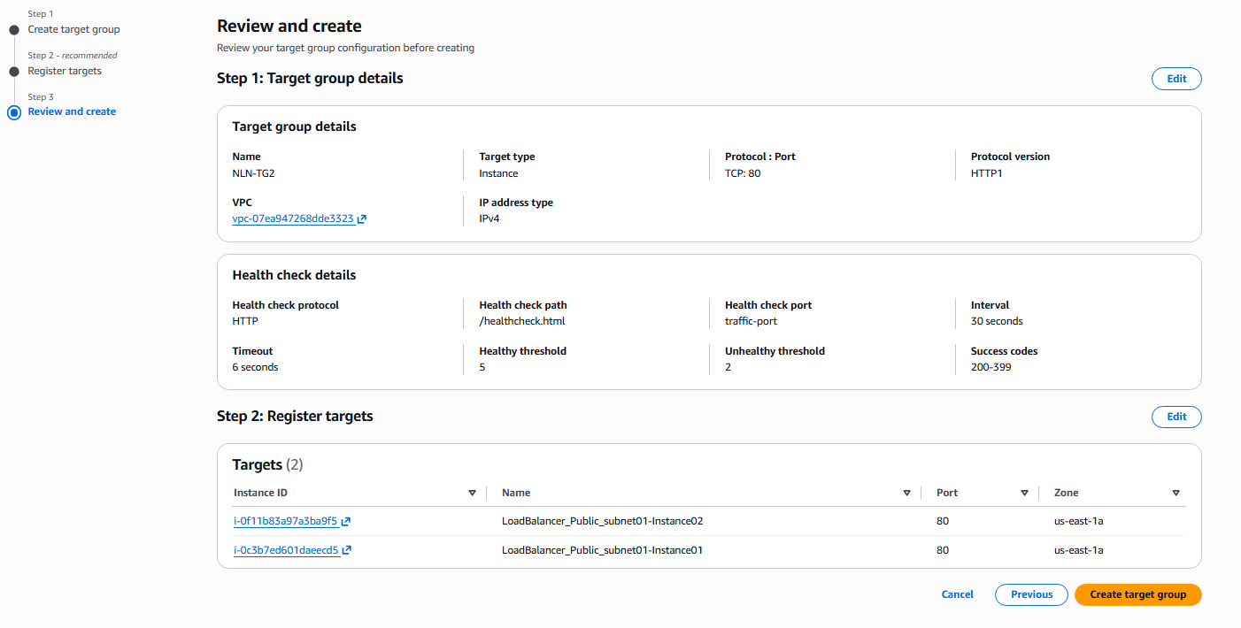

Step 3: Create Network Load Balancer
Console path: EC2 Console > Load Balancing > Load Balancers > Create Load Balancer > Network Load Balancer
Explanation: Configure the NLB to be Internet-facing and assign two subnets for high availability.
Evidence: 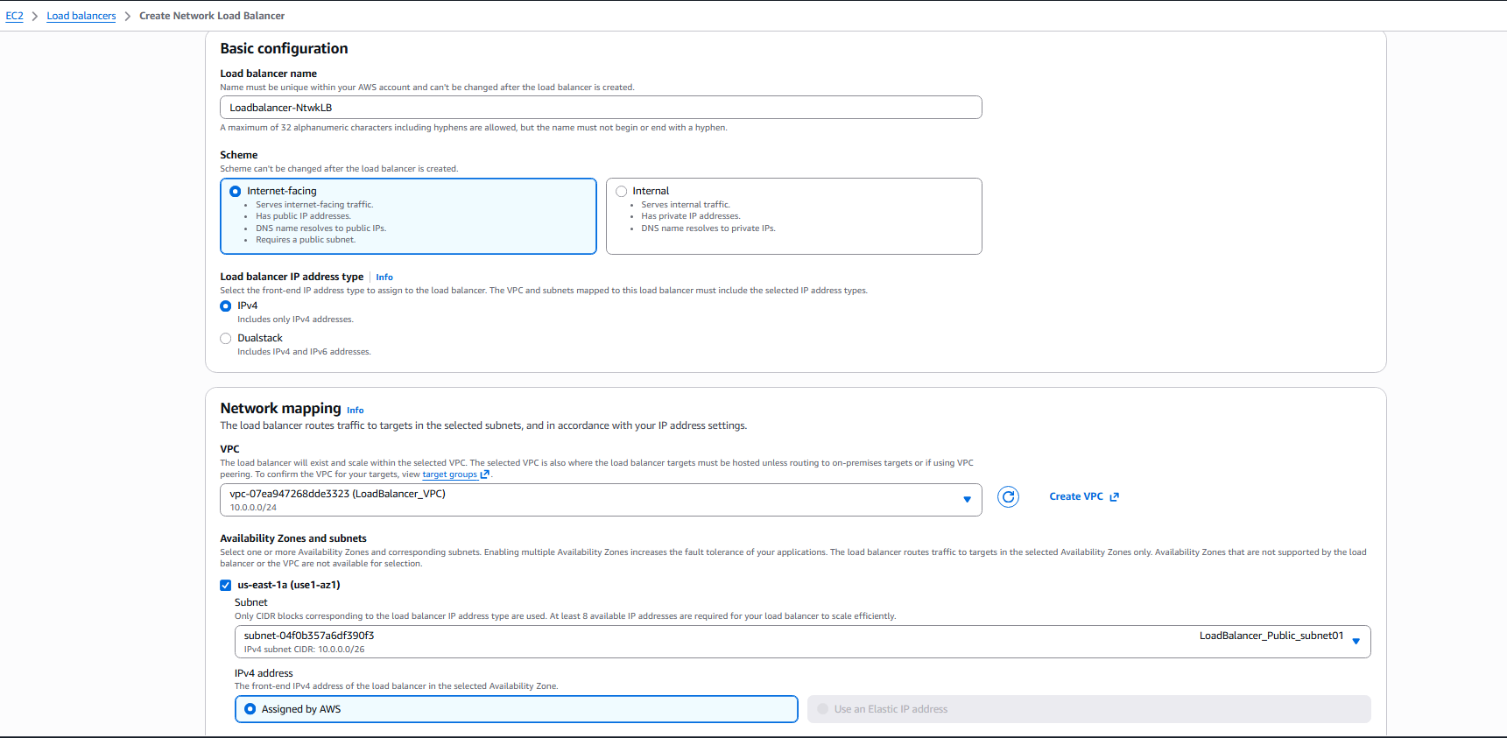 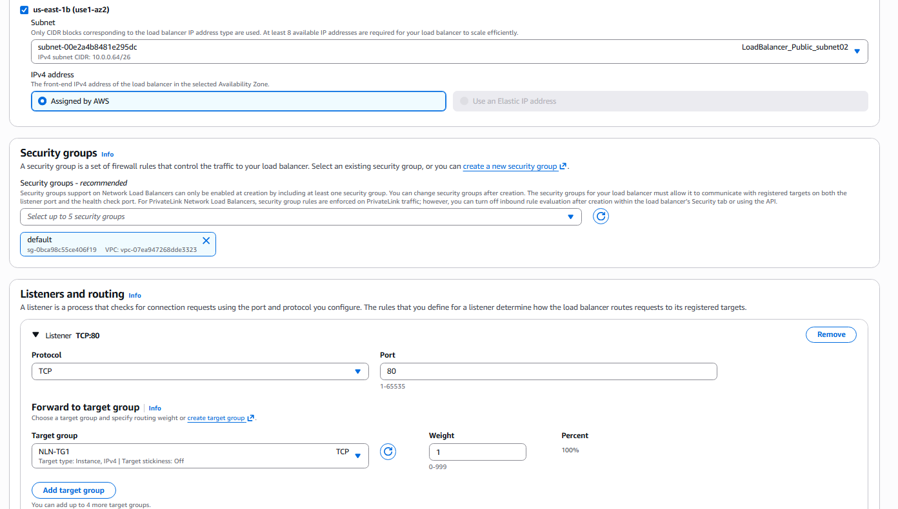 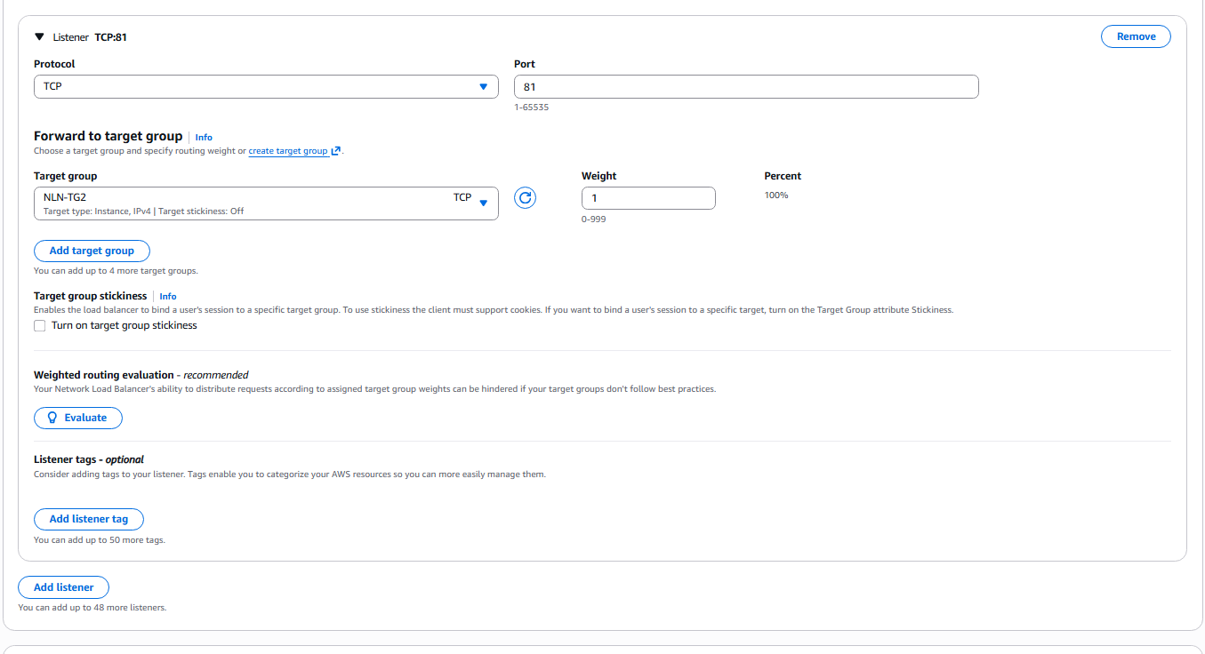 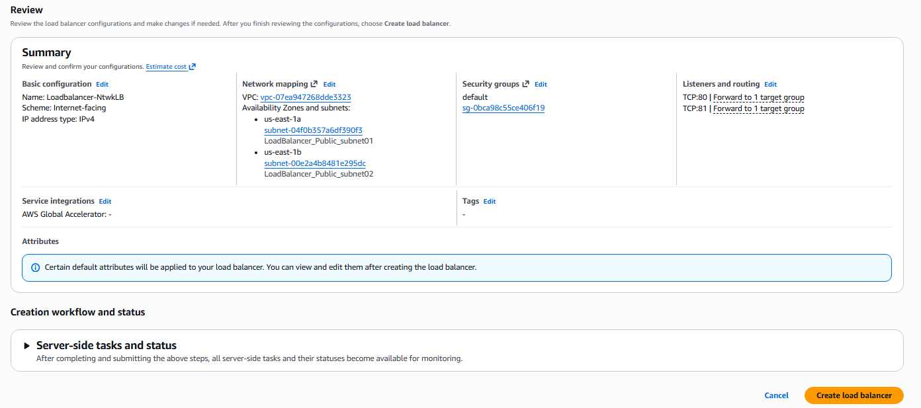

Step 4: Add Listener TCP:80 and forward to NLN-TG1
Console path: Load Balancer Creation Wizard > Listeners
Explanation: 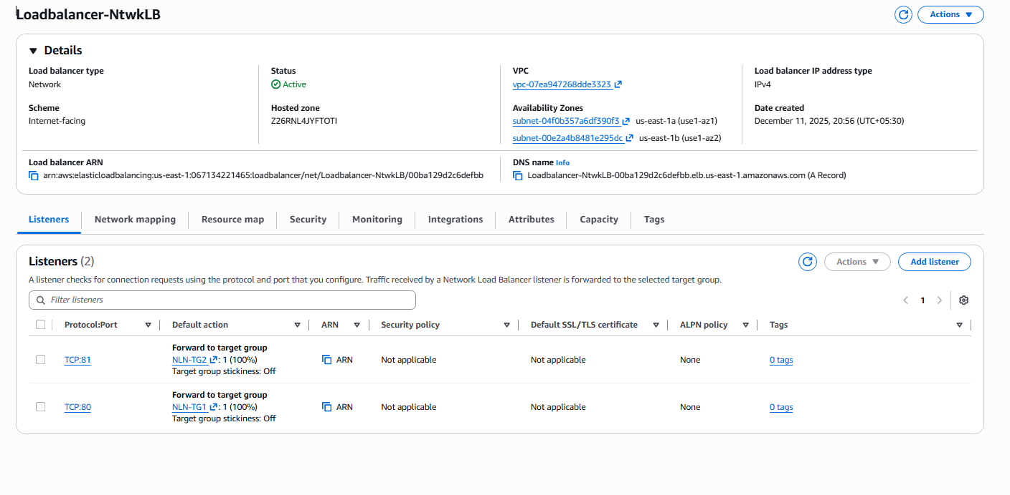

Step 5: Add Listener TCP:81 and forward to NLN-TG2
Console path: Load Balancer Creation Wizard > Listeners > Add listener
Explanation: TCP:81 listener will route traffic to NLN-TG2.
Evidence: 

Step 6: Review and Create NLB
Console path: Load Balancer Creation Wizard > Review
Explanation: Review configuration and finalize NLB creation.
Evidence: 

Validation Steps (Mandatory, With Evidence):

Validation 1: Resource Health
Example: Target groups should show targets Healthy = 2 for each.
Evidence: 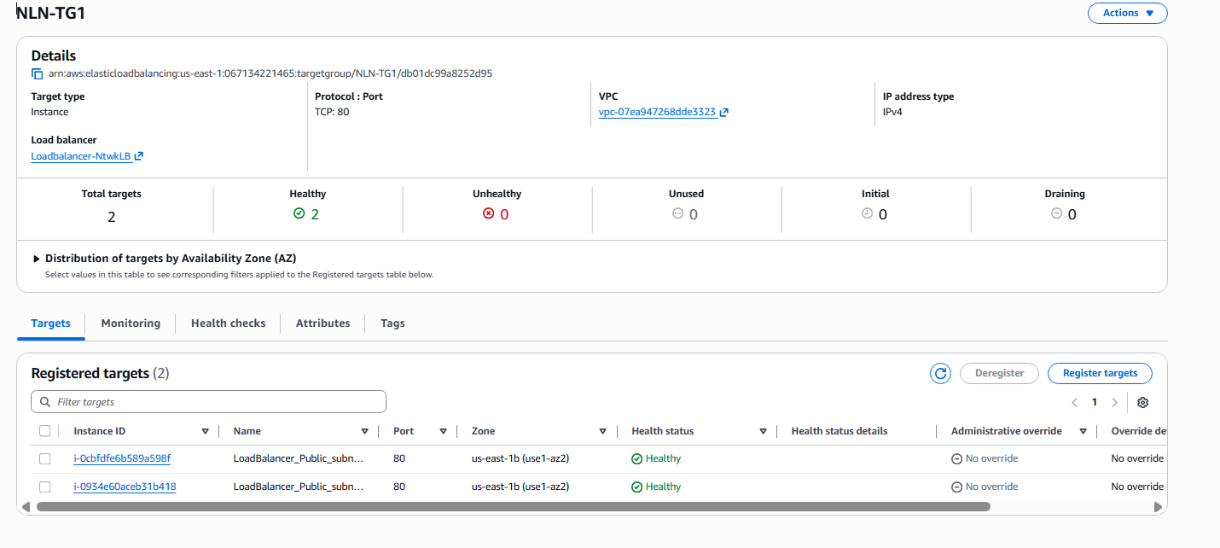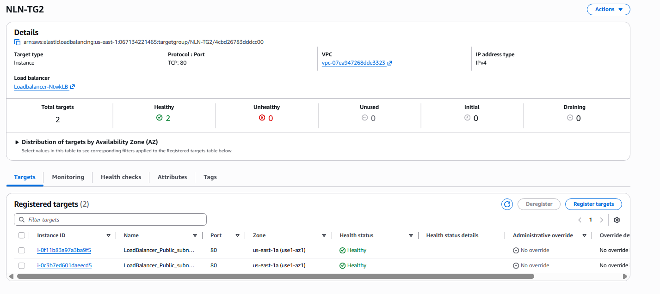

Validation 2: Access Check
Example: Confirm public access using NLB DNS name:
http://loadbalancer-ntwklb-00ba129d2c6defbb.elb.us-east-1.amazonaws.com

Evidence:

http://loadbalancer-ntwklb-00ba129d2c6defbb.elb.us-east-1.amazonaws.com:81
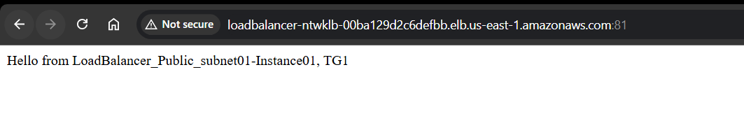 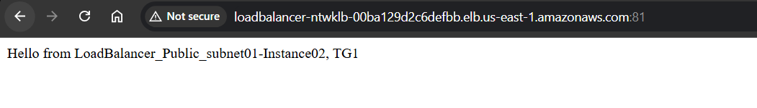 http://loadbalancer-ntwklb-00ba129d2c6defbb.elb.us-east-1.amazonaws.com:80
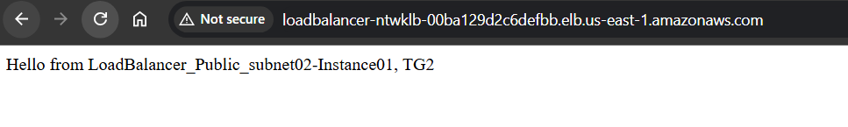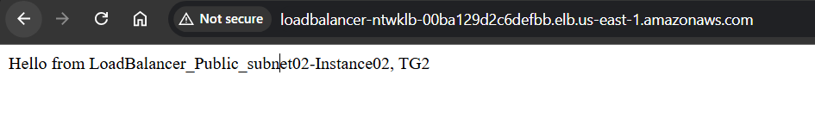
Issues Faced.
health checks failed, because I went with default healthcheck location ‘/’ initially and later when I have configured the load balancers, the healthcheck status showed health check failed, later I have changed the health check location to ‘/index.html’ where I have kept my healthcheck file, after changing the location, the health checks were successful.
• After configuring everything, it took a while to provision the Load balancer and also it took some time to get the health check status to successful status.

Conclusion:
The Network Load Balancer was configured successfully with two listeners. Traffic routed correctly to two separate target groups and all targets showed healthy. Browsing the NLB DNS confirmed responses from intended backend instances per port. The setup supports high availability and port-based traffic separation.

- Attach SSL for application load balancer, Map Application load balancer to R53.
  - Task Title: Attach SSL for application load balancer, Map Application load balancer to R53.

  - Objective:
To deploy an Application Load Balancer (ALB) with listeners on ports 80, 81, and 443, forward traffic to separate target groups (TG-1 and TG-2), validate health checks, configure SSL using Amazon Certificate Manager, and map a custom domain using Route 53. Finally, confirm successful load balancing across instances via browser output.
  - Prerequisites:
• VPC with two public subnets
• Four EC2 instances running HTTP web servers
• Security group allowing HTTP (80), HTTPS (443)
• Domain purchased and added to Route 53
• Basic HTML response configured on all four instances
• ACM certificate issued for the domain
  - Step-by-Step Implementation (With Evidence)
Step 1: Create Target Group TG-1
Console path: EC2 Console > Load Balancing > Target Groups > Create
Explanation: TG-1 will be used for port 80 listener traffic.
Evidence: 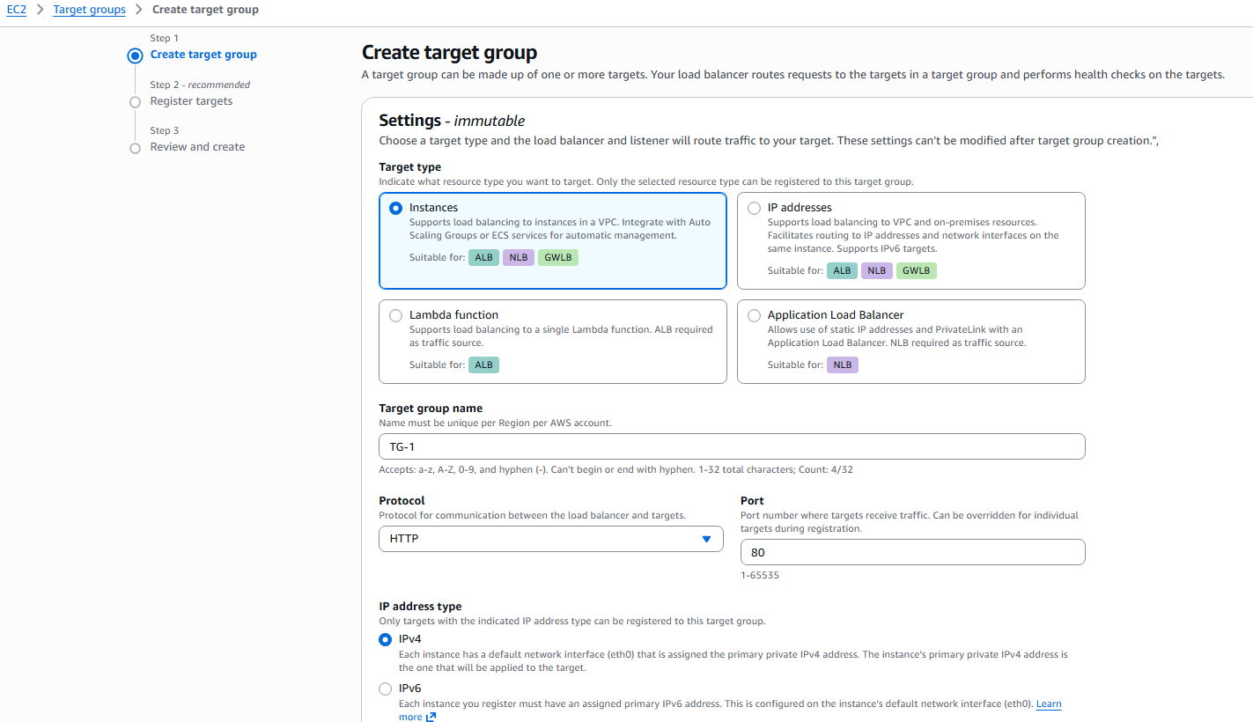 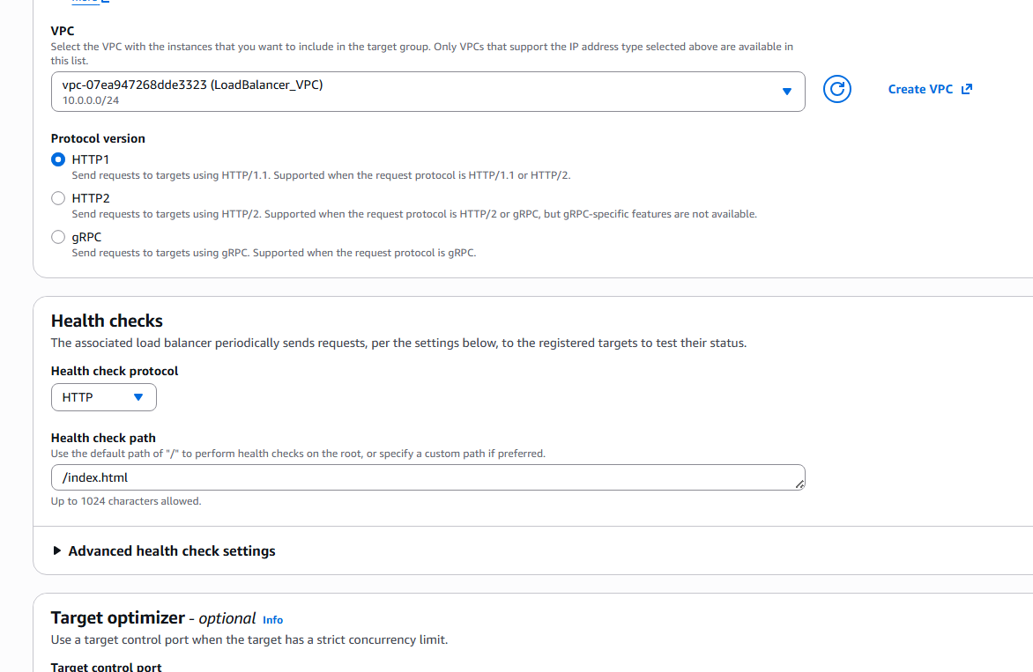 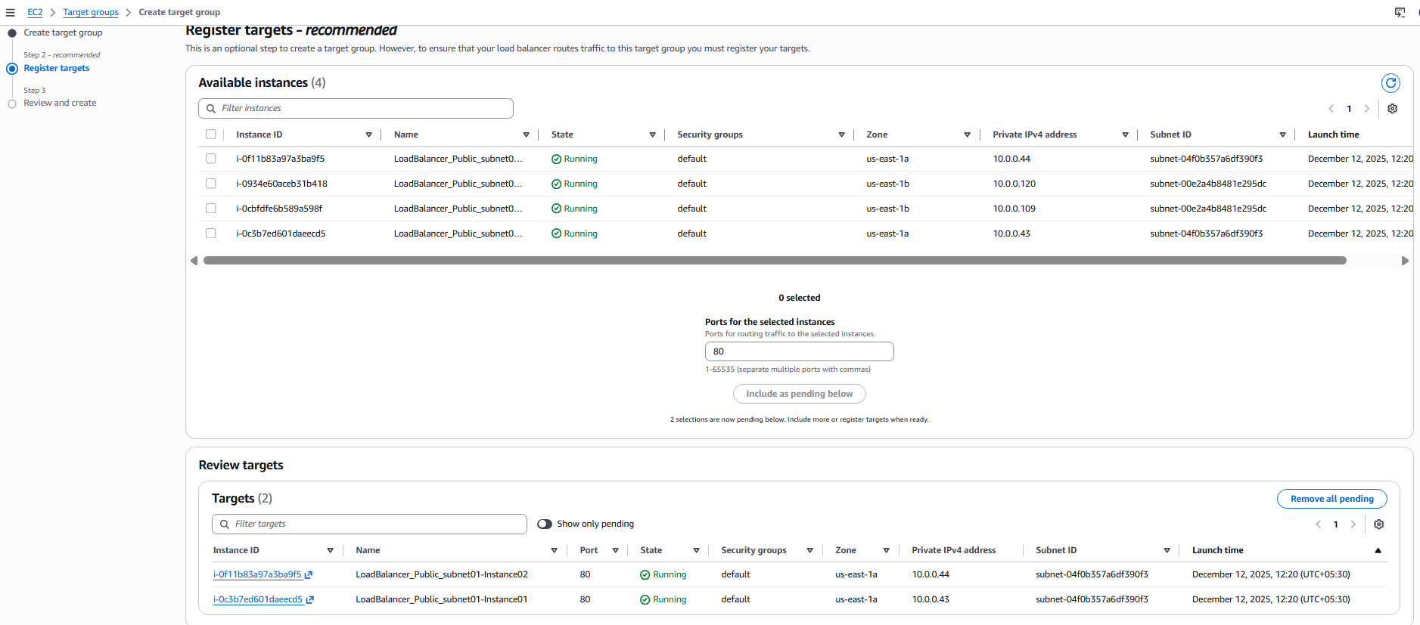

Step 2: Create Target Group TG-2
Console path: EC2 Console > Target Groups > Create
Explanation: TG-2 will be used for port 81 listener traffic.
Evidence: 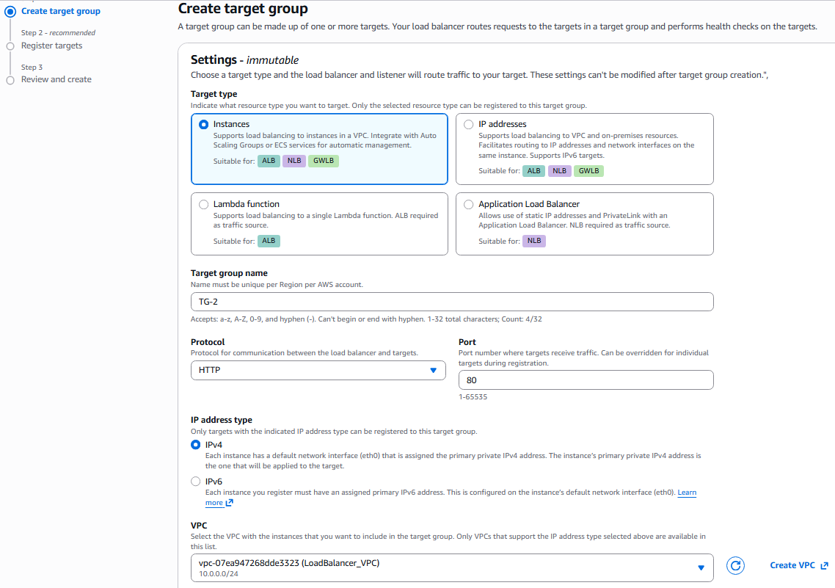 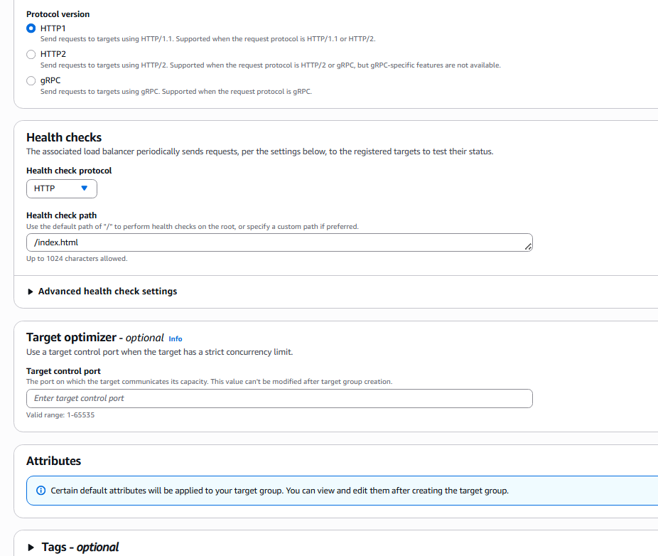 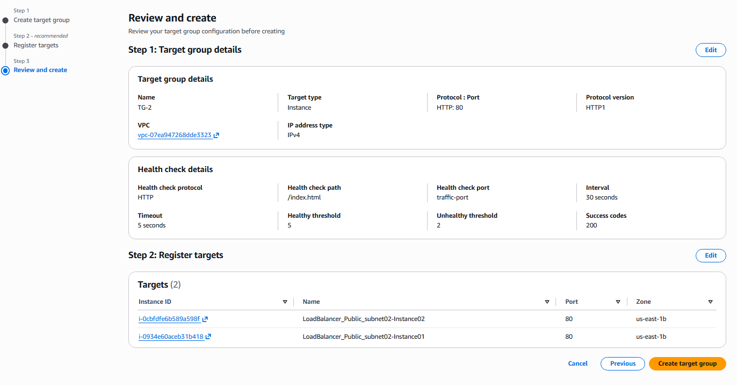

Step 3: Create Application Load Balancer
Console path: EC2 > Load Balancers > Create Load Balancer > Application
Explanation: Configure ALB with two subnets and internet-facing scheme.
Evidence: 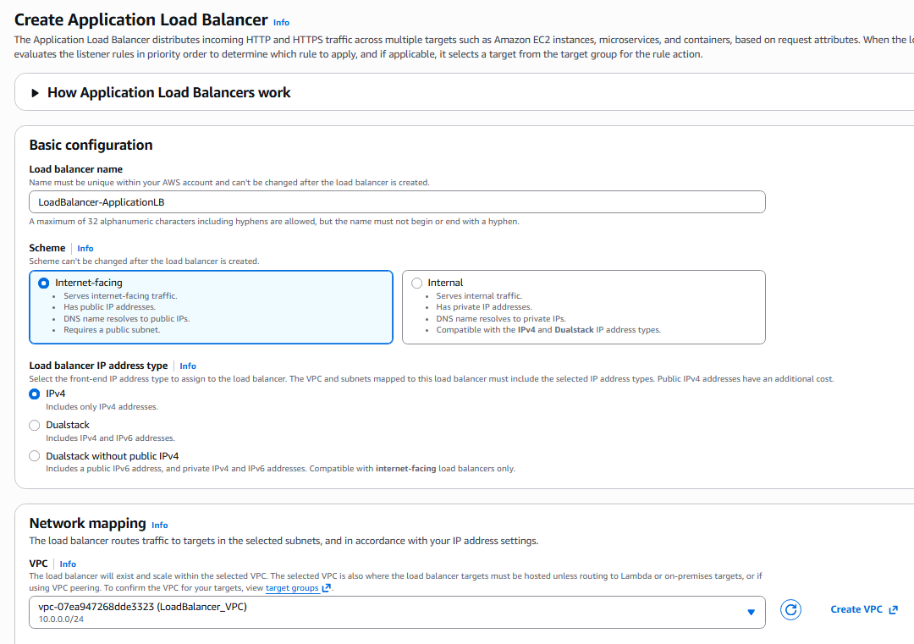 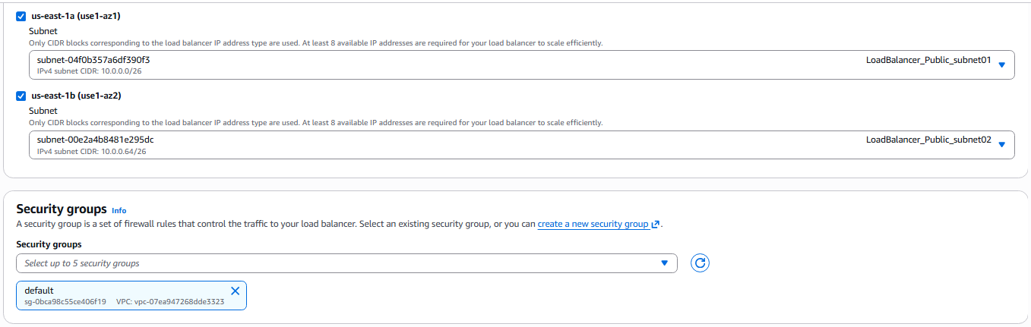

Step 4: Add Listener HTTP:80 forward to TG-1
Console path: ALB > Listeners
Explanation: Listener 80 routes to TG-1.
Evidence: 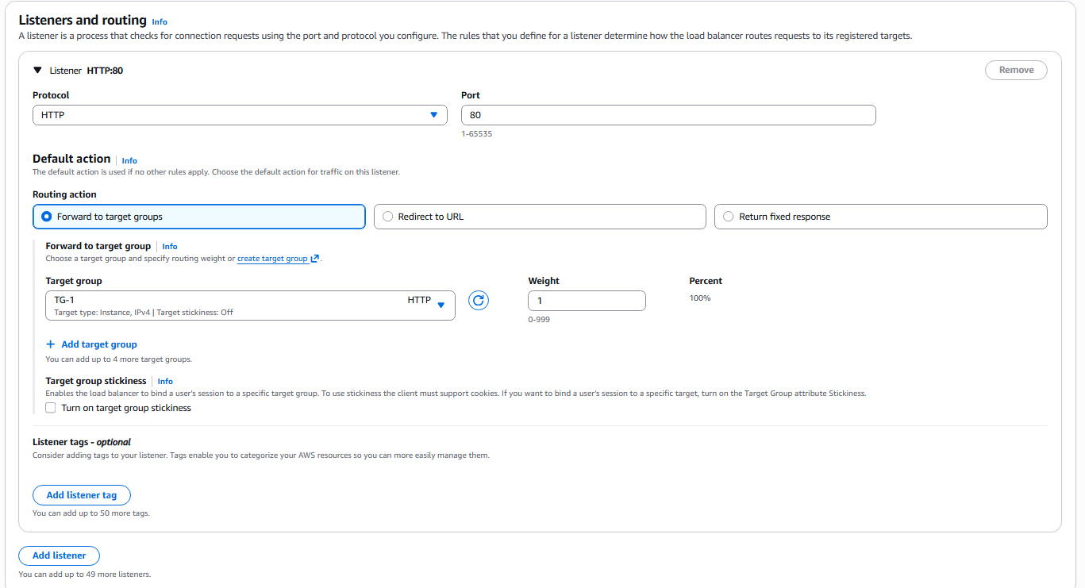

Step 5: Add Listener HTTP:81 forward to TG-2
Console path: ALB > Listeners
Explanation: Listener 81 routes to TG-2.
Evidence: 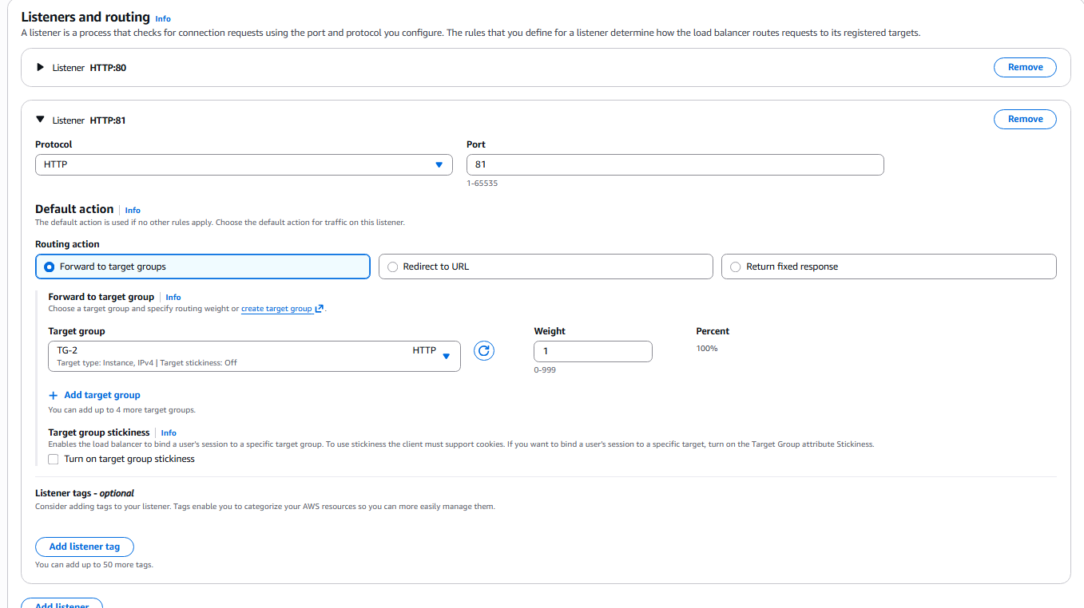

Step 6: Review and Create Load Balancer
Console path: Review section
Explanation: Review all mappings and create ALB.
Evidence: 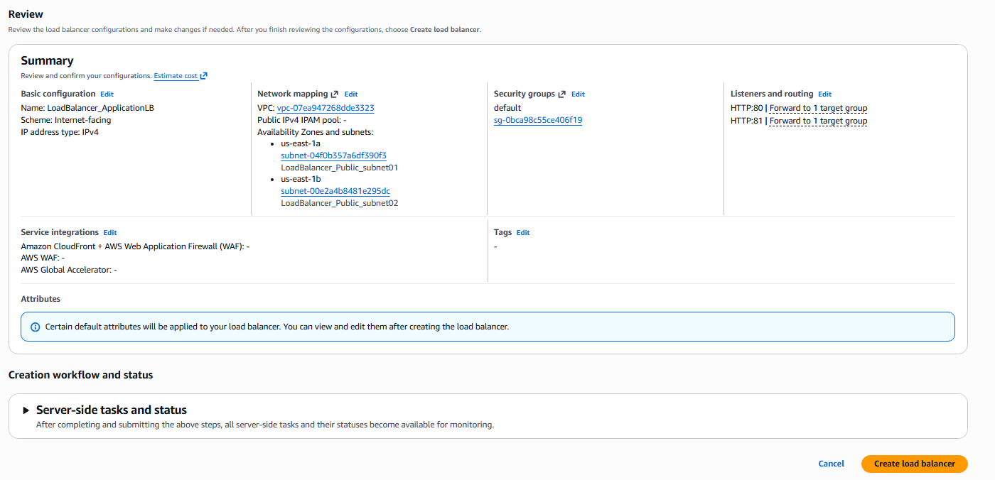

Step 7: Confirm Load Balancer Listener Status
Console path: ALB > Listeners and rules
Explanation: Ensure both listeners become active.
Evidence: 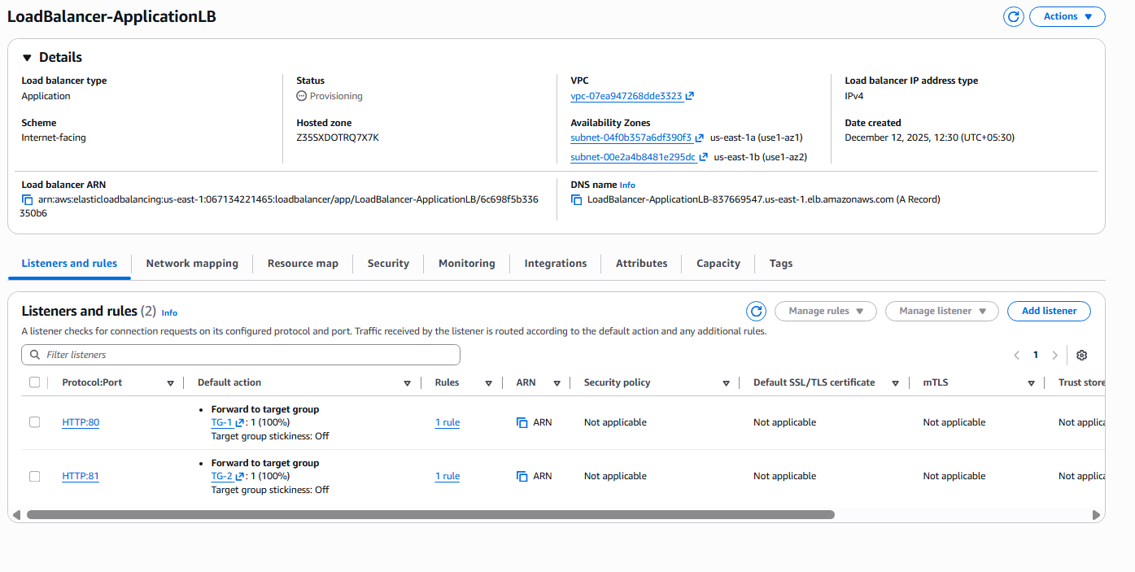

Step 8: Verify TG-1 Health Status
Console path: Target Groups > TG-1
Explanation: Ensure both instances under TG-1 are healthy.
Evidence: 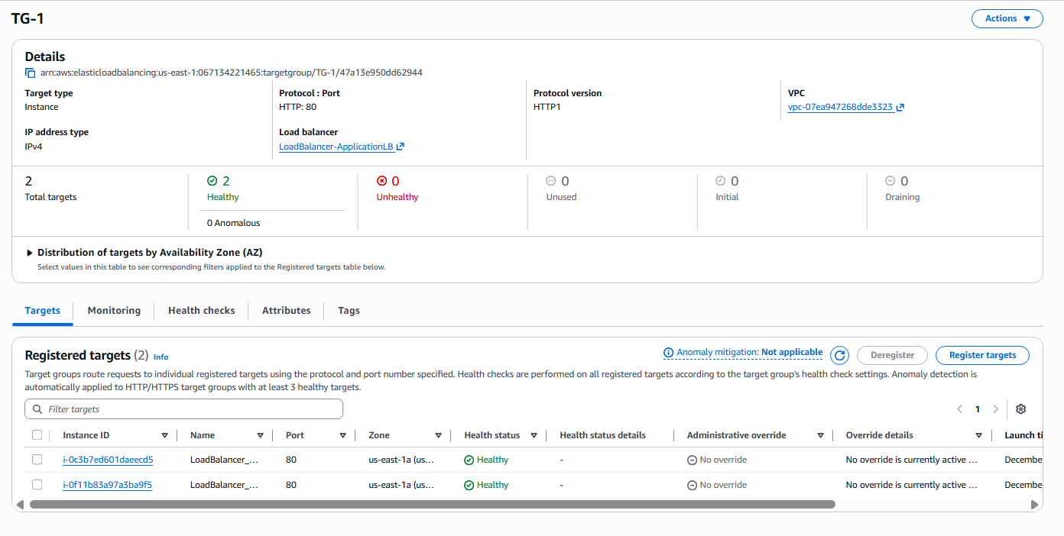

Step 9: Verify TG-2 Health Status
Console path: Target Groups > TG-2
Explanation: Ensure both instances under TG-2 are healthy.
Evidence: 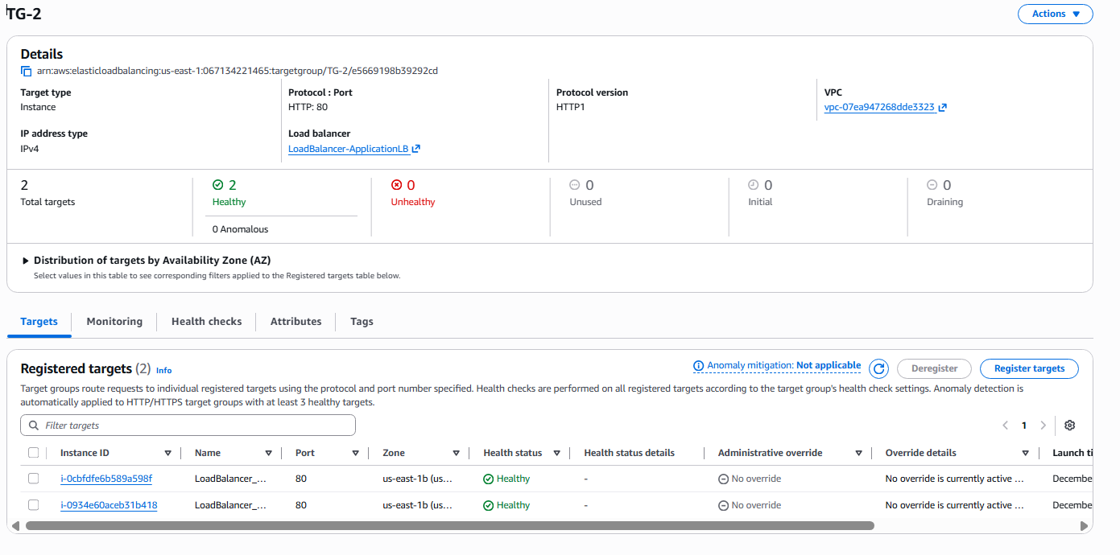

Step 10: Request Public Certificate from ACM
Console path: Certificate Manager > Request
Explanation: Request certificate for the domain.
Evidence: 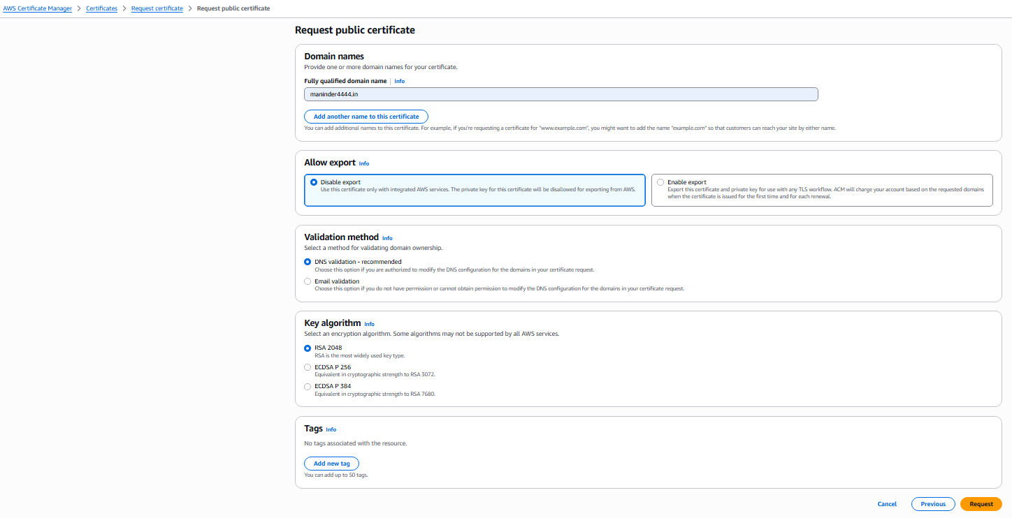

Step 11: Verify ACM Certificate Issued
Console path: Certificate Manager > Certificate Details
Explanation: Confirm certificate status is Issued.
Evidence: 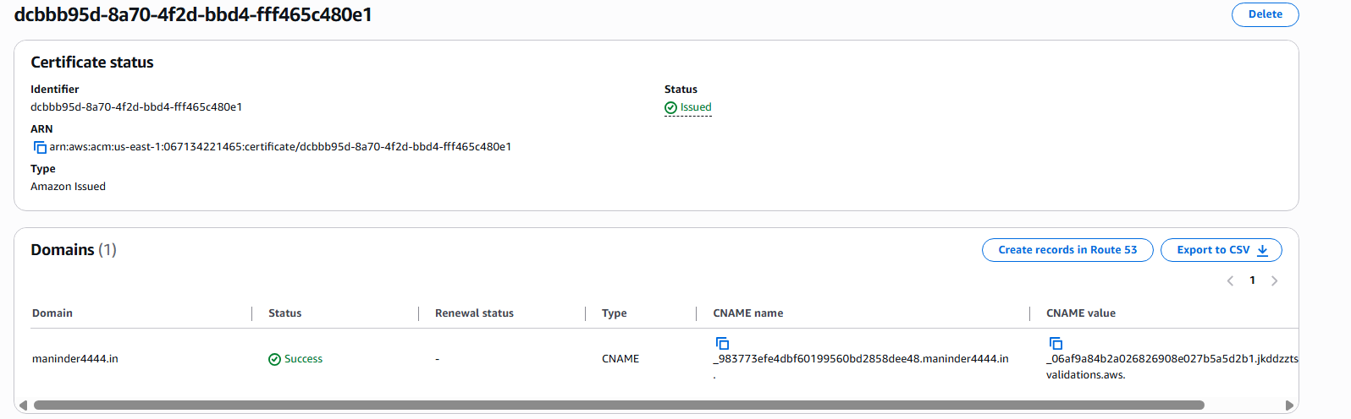

Step 12: Create Route 53 Alias Record
Console path: Route 53 > Hosted Zones > Create record
Explanation: Map domain to ALB DNS name.
Evidence: 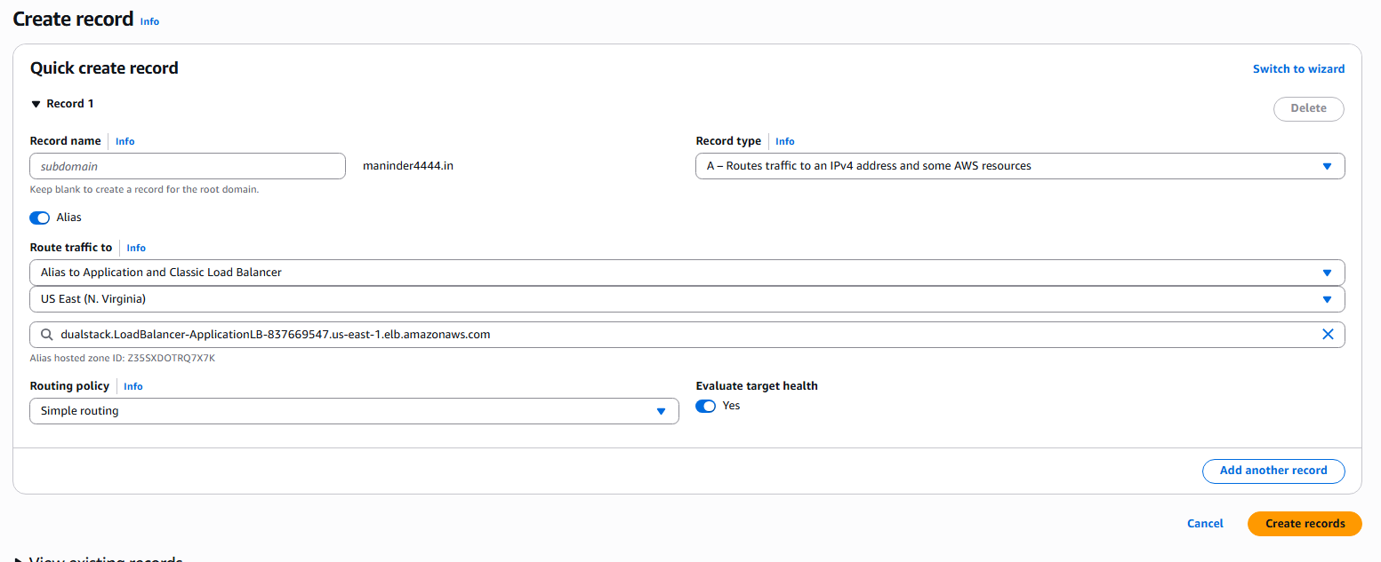

Step 13: Confirm ALB is Active
Console path: Load Balancers > Status
Explanation: Ensure ALB is fully active before testing.
Evidence: 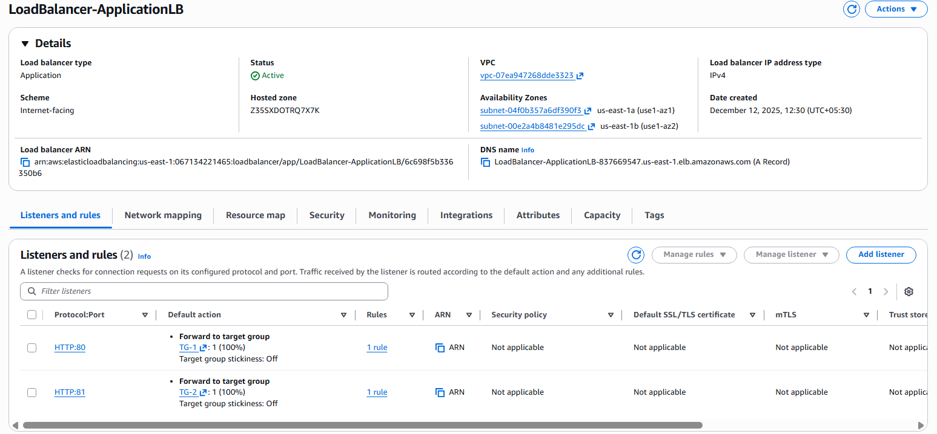

Step 14: Add HTTPS Listener (443)
Console path: ALB > Add listener
Explanation: Use ACM certificate and forward traffic to TG-1 and TG-2 with 50–50 weight.
Evidence: 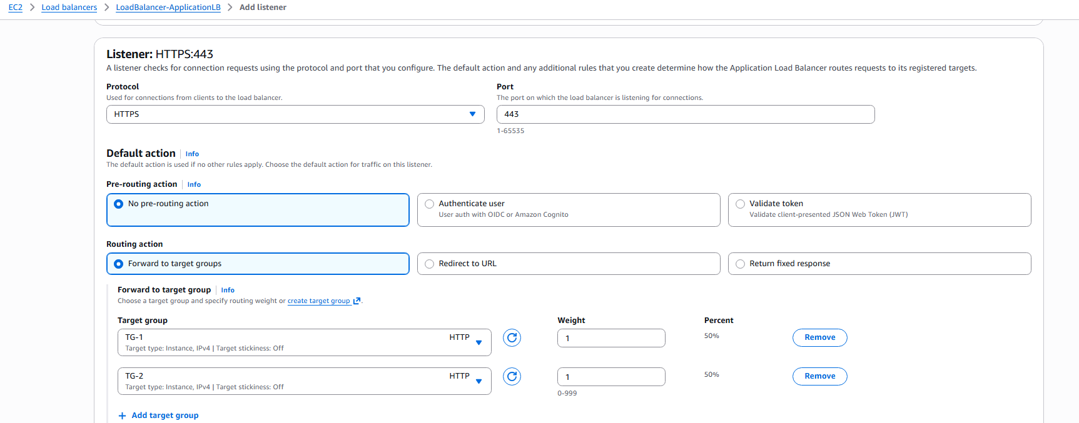 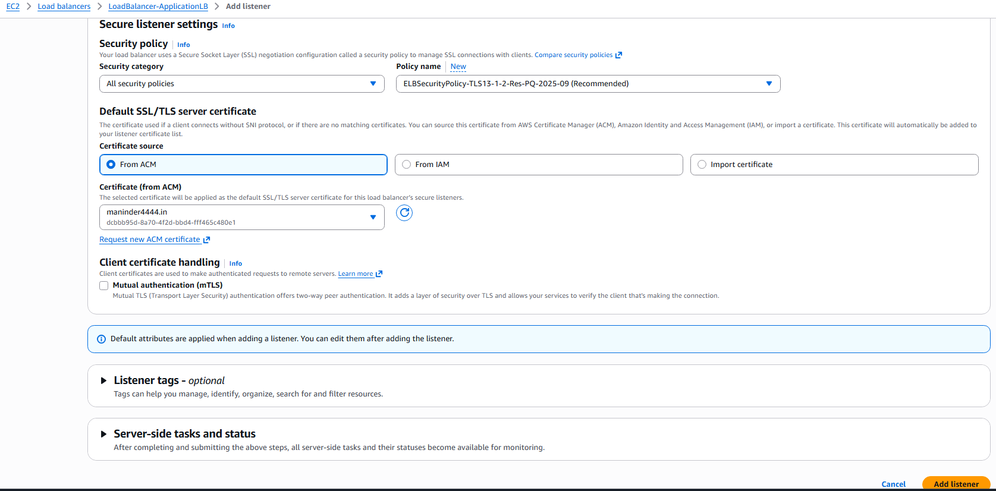

5. Validation Steps (With Evidence)

Validation 1: Confirm HTTPS listener routing works
Evidence:
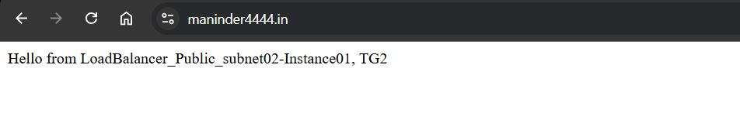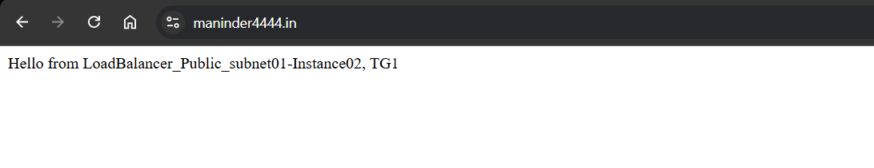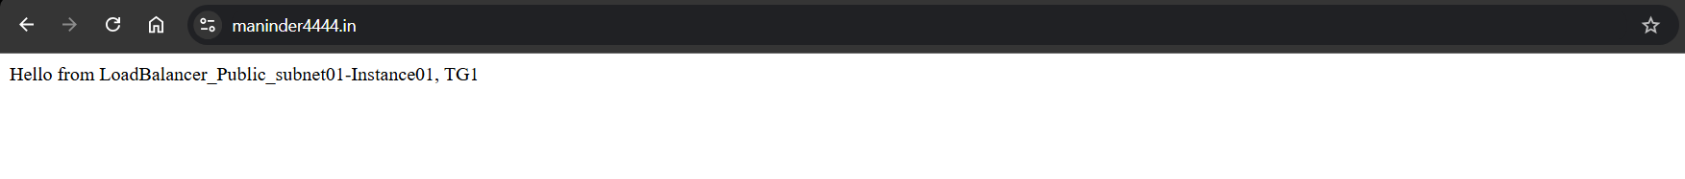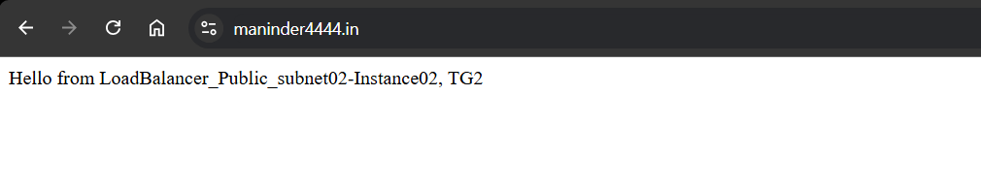
Validation 2: Round-robin traffic distribution
Explanation: The browser displays output from all four instances while refreshing maninder4444.in.
TG-1 Instance01 → 
TG-1 Instance02 → 
TG-2 Instance01 → 
TG-2 Instance02 → 

6.Issues Faced:
I have faced the error while trying to access the webpage, later I realised I have to alias to the application load balancer in A records in the Route53, after creating the A record with the Application load balancer, I was able to connect the load balancer through the domain link.
7. Conclusion:
The Application Load Balancer has been configured with HTTP and HTTPS listeners forwarding to two different target groups. The SSL certificate was successfully validated using ACM, and Route 53 alias routing was applied. Testing the domain confirms that load balancing, SSL termination, and weighted distribution across TG-1 and TG-2 are functioning properly.

- Push the application load balancer logs to S3.

- Task Title:
Push the Application Load Balancer logs to S3
- Objective:
Configure an S3 bucket and enable ALB access logging so that all Application Load Balancer access logs are delivered to the S3 bucket
- Prerequisites:
• Application Load Balancer
• An S3 bucket
• bucket policy
- Step-by-Step Implementation (With Evidence):
Step 1: Create S3 Bucket for ALB Logs
Console path: Amazon S3 > Create bucket
Explanation: Create a dedicated bucket to store ALB access logs. Ensure ACLs are enabled because ALB requires ACLs to write logs. Disable Block Public Access if required for log delivery.
Evidence:
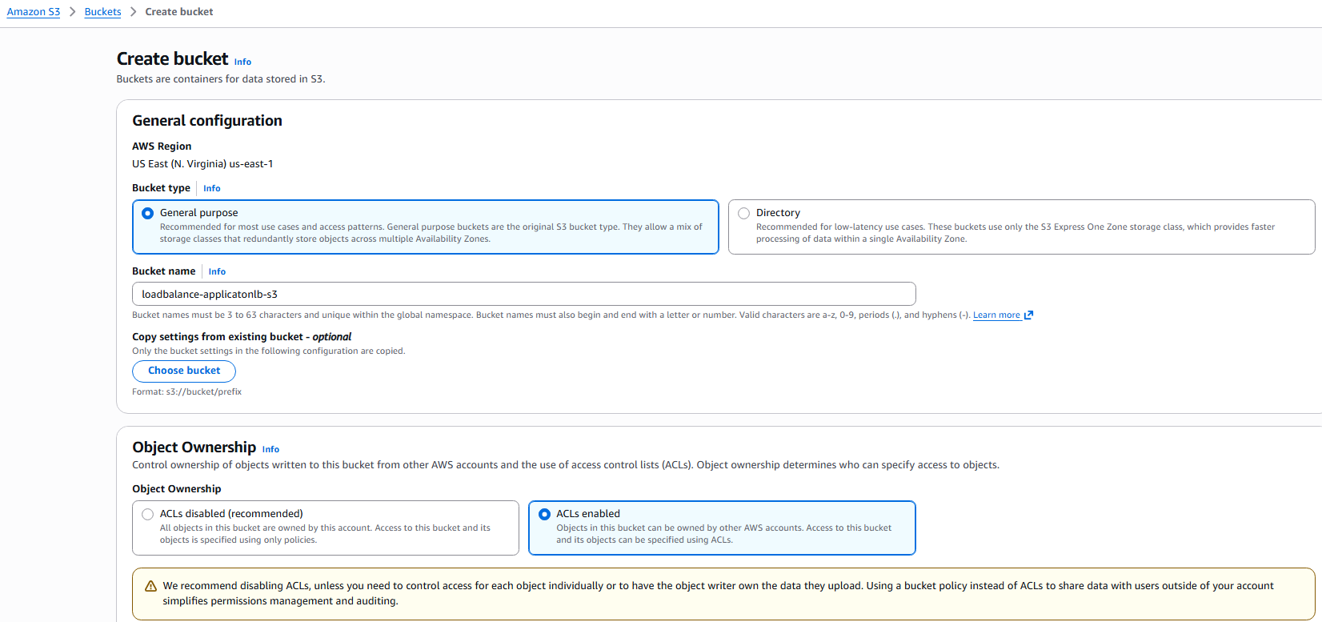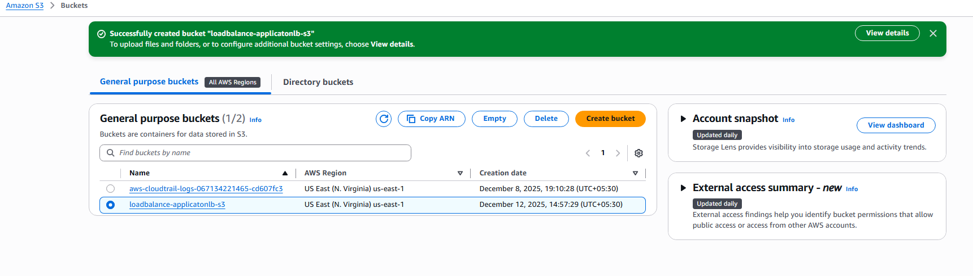
Step 2: Update Bucket Policy to Allow ALB to Write Logs
Console path: S3 > Bucket > Permissions > Bucket policy > Edit
Explanation: ALB must have permission to put log objects into the bucket. Add AWS Log Delivery service principal and allow s3:PutObject and s3:GetBucketAcl.
Evidence:
Image: 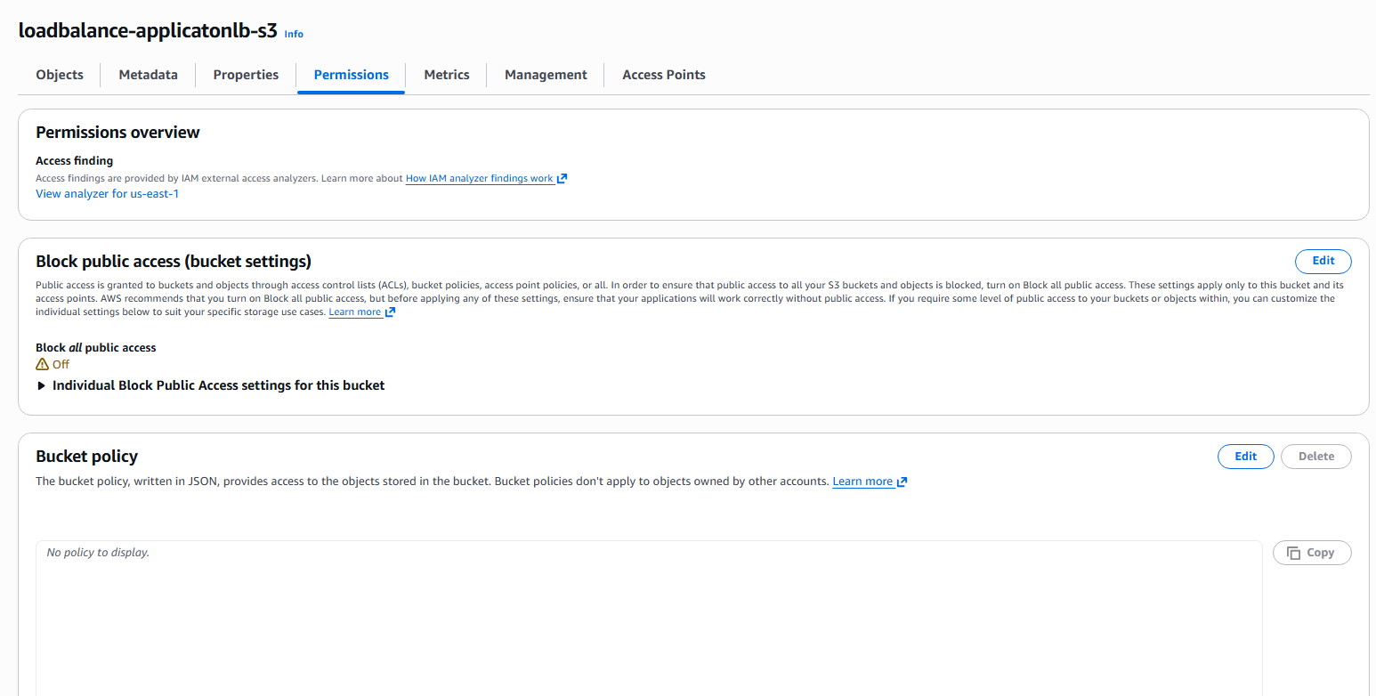
Step 3: Enable Access Logging in the Application Load Balancer
Console path: EC2 Console > Load Balancers > Select ALB > Attributes > Edit
Explanation: Enable Access logs, paste the S3 bucket ARN or S3 URL, and save changes. This activates the ALB to start pushing logs.
Policy: {
"Version": "2012-10-17",
"Statement": [
{
"Sid": "AWSALBAccessLogsPolicy",
"Effect": "Allow",
"Principal": {
"Service": "logdelivery.elasticloadbalancing.amazonaws.com"
},
"Action": "s3:PutObject",
"Resource": "arn:aws:s3:::loadbalance-applicatonlb-s3/AWSLogs/067134221465/*"
},
{
"Sid": "AWSALBAccessLogsBucketPermissionsCheck",
"Effect": "Allow",
"Principal": {
"Service": "logdelivery.elasticloadbalancing.amazonaws.com"
},
"Action": [
"s3:GetBucketAcl",
"s3:ListBucket"
],
"Resource": "arn:aws:s3:::loadbalance-applicatonlb-s3"
}
]
}
Evidence:
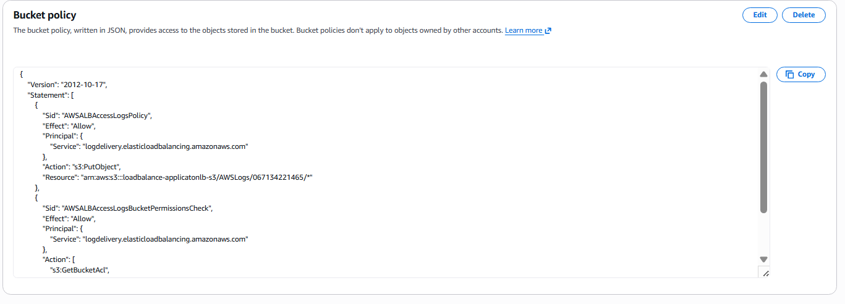
Step 4 Confirm Log Folder Structure
Console path: S3 > Bucket > AWSLogs > AccountID
Explanation: ALB creates an AWSLogs folder where logs are stored in date-based prefixes.
Evidence: 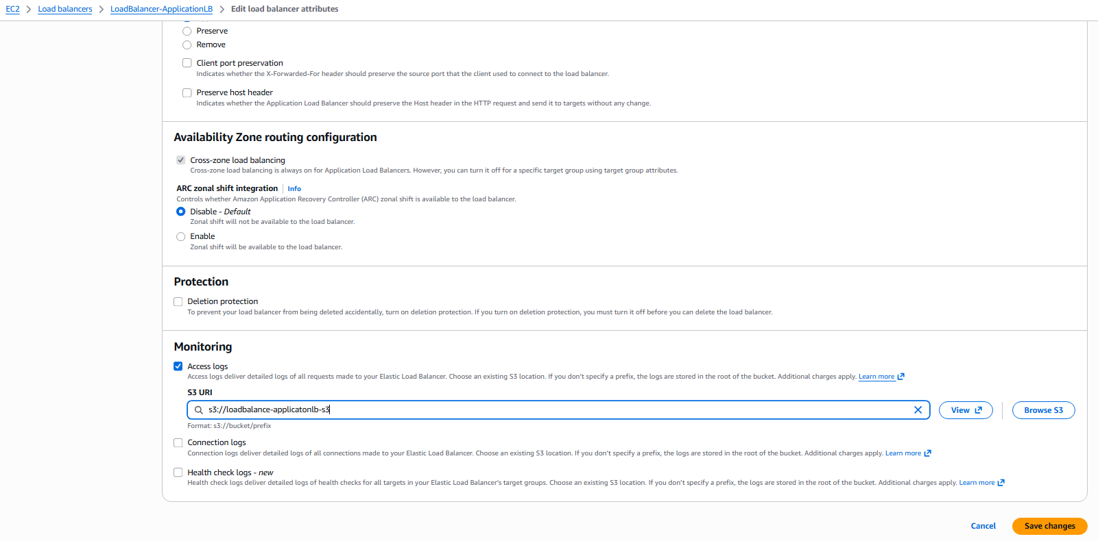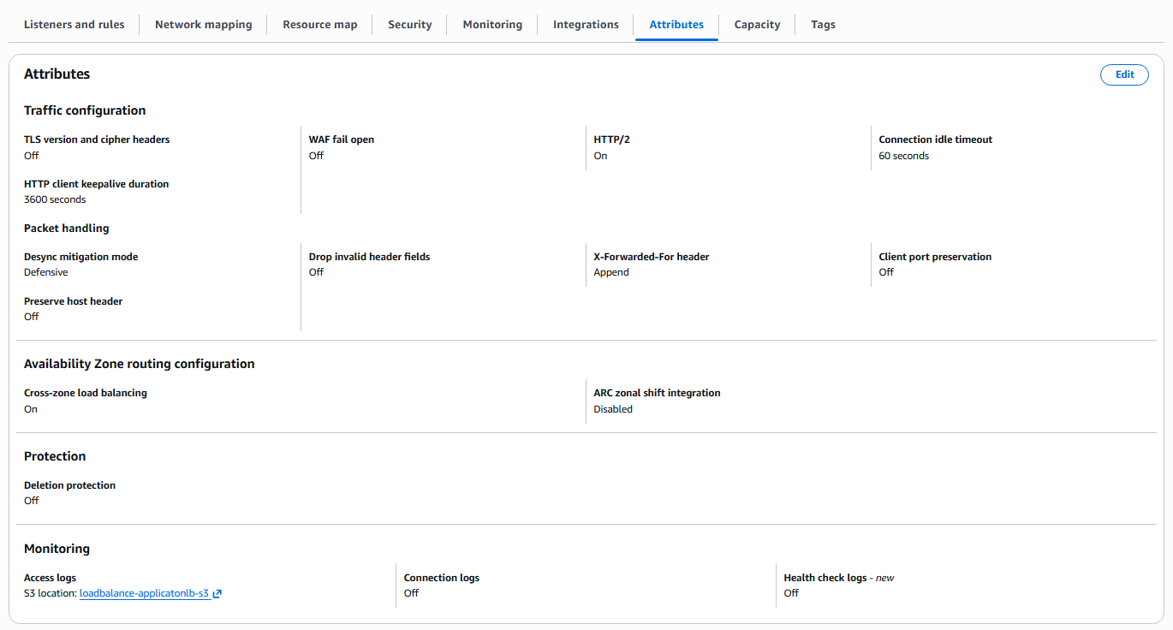
Validation Steps (Mandatory, With Evidence):

Validation: Access Check
Example: Confirm logs appear in the S3 bucket after enabling logging.
Evidence:
Screenshot: 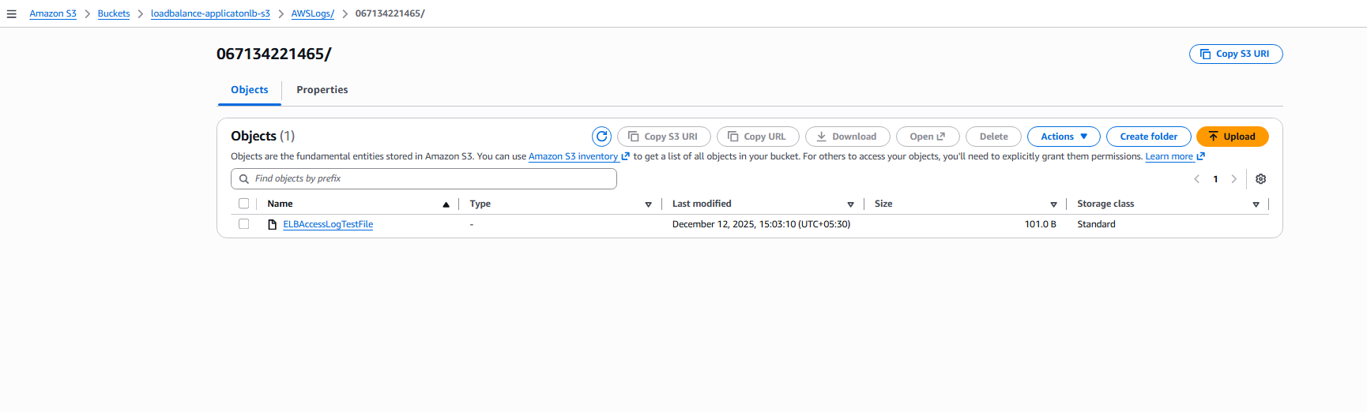

- Conclusion:
The Application Load Balancer was successfully configured to push access logs to S3. The S3 bucket was created, permissions were applied, ALB logging was enabled, and validation confirmed that logs were delivered to the correct folder. This setup now supports auditing, monitoring, and troubleshooting for all ALB traffic.

